**Software Documentation for the Human Resource Management System**

**Product Name: HRMS**

Release Version:

Testing Started:

Testing Completed:

Technical Lead:

Product Owner: BBA

Primary Tester:

Developer:

Types of Test Performed:

**Browser Tested:**

1. Chrome

2. Mozilla Firefox

**Device Tested:**

1. Desktop

2. Laptop

3. Tab

4. Smartphone

**Instance Tested:**

1. Development

2. Testing

3. Production

4. UAT

**Table of Contents**

Revision History 4

Design Specification 5

Abstract 6

Chapter-1: Introduction 7

1.1 Review of the HRMS 7

1.2 Motivation 7

1.3 Goals 7

1.4 Solution Methodology 8

Chapter - 2. Background Study 9

2.1 Human Resource Management System 9

2.2 Why should we use this software system ? 9

2.3 User Experience 9

2.4 Employees Information 9

2.4.1 All Employees List 9

2.4.2 Education List 9

2.4.3 Employees child List 9

2.4.4 Employees promotion/charge List 9

2.4.5 Employees Training List 10

2.5 Employees Loan Request 10

2.6 Employees Leave Request 10

2.7 Employees Health Records 10

2.8 Discipline Details 10

2.9 Event Management 10

2.9.1 Dashboard 10

2.9.2 Calender 10

2.9.3 Event 10

2.10 Settings 10

2.10.1 Roles & Permissions 10

2.10.2 Users 10

2.10.3 Leave Types 11

2.10.4 Document Types 11

2.10.5 Health Information 11

2.10.6 Punishment 11

2.10.7 Departments 11

2.10.8 Designation 11

2.10.9 District 11

2.10.10 Loan Funds 11

2.10.11 Leave Types 11

2.10.12 Grades 11

2.10.13 ACR Class 11

2.10.14 ACR type 11

2.6 Report & Analysis 11

2.7 HRMS main modules 12

2.8 Benefits of HRMS 12

Chapter – 3: Software Requirement Analysis 13

3.1 Introduction 13

3.2 Requirement 13

3.3 Software Requirement Specifications 13

3.3.1 SRS Scopes 13

3.3.2 Functional Requirements 13

3.3.3 Non-functional Requirement 14

3.4 Interface Requirement 14

3.4.1 User Interface 15

3.4.2 Hardware Interface 15

3.4.3 Software interface 15

3.4.4 Communication Interface 15

3.5 SRS table 15

3.6 Report Analysis 16

Chapter – 4: System Design 19

4.1 Algorithm Design 19

4.2 Process Flow Diagram 20

4.3 Data Flow Diagram 21

Chapter – 5: Testing Documentation 23

5.1 Introduction 23

5.2 Scopes 23

5.3 Quality Objective 23

5.4 Testing Methodology 23

5.4.1 Model 23

5.4.2 Strategies 24

5.4.3 Levels 24

5.4.4 Test Deliverables 24

5.4.5 Tools 24

5.5 Testing web pages with Result 25

# Revision History

|  |  |  |  |
| --- | --- | --- | --- |
| Date | Version | Description | Author |
|  |  |  |  |
|  |  |  |  |
|  |  |  |  |
|  |  |  |  |

# Design Specification

**Overview:**

Human Resource Management System is the most important part of the Management Control System(MCS). This HRMS contains just a little sub-modules and client side and server side maintenance area. Back-end and front-end part control the functionality of the system.

**Back-end parts:**

1. Node.js

2. Database → Oracle

3. MS Server Version 2.0

**Front-end parts:**

1. React.js

2. Bootstrap

3. Domain → Friendly

# Abstract

Human Resource Management System capture the large environment of a software system. This module manages all the terms related to other modules. Form employee maintenance to employee working area, all need to be described in the Human Resource Management System. This software system should conclude employee types, their personal details, their discipline, loan, cause of leaving, event management, and so on. So, our aim is to design a software system than can perform all of these task through an admin for the several modules and sub-modules. For this reason we have to do a system design and requirement specifications to visualize the entire functionality of the Human Resource Management System (HRMS).

# Chapter-1: Introduction

## 1.1 Review of the HRMS

Human Resource Management System has been studied in the last few decades. It is highly recognized for its impact to the organizational performance. The objectives is to present the strategic and systematic way to figure out HMRS. A perfectly planned HMRS can make the system more efficient and helpful in a organization.

## 1.2 Motivation

For the purposes of managing the management control system, we had to design a HRMS tha can handle all sorts of employees information. This system can operate all the terms and tasks related to the employees. We try to design such type of software system that can maintain several types of operation at a time without wasting time, less money and having smooth behavior.

## 1.3 Goals

Our aims is to achieve a better Human Resource system that has ability to fulfill our requirements.

* Platform Independent
* Auto Synchronizing
* Friendly Environment
* Domain and Hosting
* Employee Maintenance
* Employees Roles and Permissions
* Approval Request & Status
* Generate Each section Report
* Multi-functionality

## 1.4 Solution Methodology

1. Design Settings

2. Design Employees Information

3. Design Educational, children information, promotion/charge, training information

4. Design Employee Loan, loan, leave, health, punishment details

5. Assigning Event Management Details

6. Employee Dashboard

Event Management

Dashboard

Manage Settings

Employee official

information

Employee Personal

Details

Add Employee

# Chapter - 2. Background Study

## 2.1 Human Resource Management System

Human Resource Management System is the strategic approach to the effective and efficient management of people in a organization to gain better advantage. It is basically maximize employee performance. It is the practice of recruiting or hiring and deploying employees.

## 2.2 Why should we use this software system ?

We use this software system to create the best use of employees. In each area of mechanism of the software system, one can do multiple operation in a single user login. We have to use this software to reduce taking much manpower, optimal cost and time savings while in manually it needs much time.

## 2.3 User Experience

Human Resource Management System is used by the user’s to operate the Human Resource system. An user can easily handle the software. Less complexity in the system can make user experience more better.

## 2.4 Employees Information

### 2.4.1 All Employees List

This sub-module provide the functionality that can add all employees information and make a list of them. From that list one can find employee details by searching through specific employee name.

### 2.4.2 Education List

Admin can add educational qualification of an employee in this module. Admin can also do an operation in the existing employee.

### 2.4.3 Employees child List

Admin can add children for an employee that is listed on the employee list. Children details are presented in that list.

### 2.4.4 Employees promotion/charge List

This section includes the promotion or charge of an employee, add their designation and employees details information about promotion.

### 2.4.5 Employees Training List

Training information of an employee are stored through this section. Training title and all materials are added to this form.

## 2.5 Employees Loan Request

If an employee want to make a loan request, admin make a form of loan request and make a list of them. Loan form includes all the loan related information.

## 2.6 Employees Leave Request

An employee can make a leave request by this section. For this reason, an employee should show leave cause, leave duration and necessary information for leave request.

## 2.7 Employees Health Records

Employee health details are recorded in this form like height, weight, blood pressure, visual power etc.

## 2.8 Discipline Details

This section explain the punishment for breaking the rules and regulation of any discipline. Discipline details give the clear information about punishment information, describe offence and other document view of discipline details.

## 2.9 Event Management

### 2.9.1 Dashboard

Dashboard shows the overview of all the events. One can show the event details by clicking the specific region of the event.

### 2.9.2 Calender

Form the calender, event manager can find day to day event list. Form this section, assigning employee or reschedule can be done.

### 2.9.3 Event

A new event can be created through this section. While creating event, admin can add all the event details like event title, assign employee, category etc.

## 2.10 Settings

### 2.10.1 Roles & Permissions

Admin can add an user to play a role for a mentioned module like lease admin, transport admin, etc. Admin can assign them for those programs.

### 2.10.2 Users

Admin can add users through username and playing role. Admin can also has functionality to make user enable or disable.

### 2.10.3 Leave Types

This section can add all leave types that users can make leave request.

### 2.10.4 Document Types

How many types can be uploaded that can be added in this section.

### 2.10.5 Health Information

Admin can add health information for the users can explain them in health record form.

### 2.10.6 Punishment

For breaking discipline, the punishment form include the type of punishment and the charge for this reason.

### 2.10.7 Departments

Admin add all the department in the area of Management Control System.

### 2.10.8 Designation

All employees designation and their grade are added in this section.

### 2.10.9 District

Employees available district are added through this form.

### 2.10.10 Loan Funds

New loan funds name are added for the loan request purposes.

### 2.10.11 Leave Types

Leave types explain the leave request reason that are titled by leave types.

### 2.10.12 Grades

This section provides the grade and payscale start and end as well as their salary details. Admin can generate all of these task.

### 2.10.13 ACR Class

Admin can add ACR class.

### 2.10.14 ACR type

Admin can add ACR type.

## 2.6 Report & Analysis

In the module named by Human Resource Management System, the information provided by the user can be generated by a document format so that it can be used physically. While generating report, there has a option to each documents as our requirement needs.

## 2.7 HRMS main modules

* Login Functionality
* Dashboard
* All employees
* education, children,promotion/charge,training
* Loan, leave, Health, Discipline, Events Management
* Settings
* Report analysis

## 2.8 Benefits of HRMS

* Reduce taking of excessive manpower
* saving money and time
* preplanned thinking to develop for next generation software system.

# Chapter – 3: Software Requirement Analysis

## 3.1 Introduction

A software requirement is a field within software engineering that deals with establishing

the needs of stakeholders that are to be solved by software. The IEEE Standard Glossary of

Software Engineering Terminology defines requirements.

## 3.2 Requirement

The HR Management System Requirements provides high-level of functional requirements.

## 3.3 Software Requirement Specifications

* Documentation (user and administration)
* Operational behavior
* Employee Information
* Manage Employee Details
* Technical Support

### 3.3.1 SRS Scopes

In according the lease act, the following information should be provided and stored.

1. Unique Login Id

2. Employees Personal and official information

3. Summary dashboard

4. Settings for Product entry

### 3.3.2 Functional Requirements

Every section has a specific functionality that’s are given below:

* Login – admin
* Dashboard – automatically generated.
* Role - add employee, users.
* Report – download a copy of corresponding section.

### 3.3.3 Non-functional Requirement

For an specific criteria, there should be applied non-functional requirements which are

shortly described below:

**Reliability**

The operational interface can’t fail within a period of time.

**Availability**

The system is available or not while a user wants access the information.

**Security**

All user can login to the system with secured procedure. Each user has a unique

identification system. Admin can store user’s login information.

**Maintainability**

All source code and related document should be controlled under a version of the

system.

**Portability**

As the software run into several platform, the platform independence should be ensure.

Different OS can access the software easily.

**Usability**

The Software should be easy to use and given a positive experience by the

user’s.

## 3.4 Interface Requirement

Computer system including software and hardware can turn the system on by interfacing

them with human thought.

### 3.4.1 User Interface

1. Login Screen
2. Home Screen
3. Employees Information
4. Control settings

### 3.4.2 Hardware Interface

• Server Config.

• CPU/Processor

• Windows with apache preloaded

• Client Config.

### 3.4.3 Software interface

• OS = Windows, Linux

• Language = PHP, JS

• DB = Oracle

### 3.4.4 Communication Interface

These interfaces include E-mail, Web Browser, Server Network and use http or ftp for

security purposes.

## 3.5 SRS table

It describes necessary behavior of the software system and shows in the table 3.1.

|  |  |  |
| --- | --- | --- |
| SI.No. | Requirement Name | Requirement Classified |
| 1. | Employees |  |
| 2. | Education |  |
| 3. | Children |  |
| 4. | Promotion/Charge |  |
| 5. | Training |  |
| 6. | Loan |  |
| 7. | Leave |  |
| 8. | Health |  |
| 9. | Discipline |  |
| 10. | Event Management |  |
| 11. | Roles & Permissions |  |
| 12. | Users |  |
| 13. | Loan type |  |
| 14. | Document Type |  |
| 15. | Health Information |  |
| 16. | Punishment |  |
| 17. | Departments |  |
| 18. | Designation |  |
| 19. | Districts |  |
| 20. | Loan funds |  |
| 21. | Loan Funds |  |
| 22. | Leave Types |  |
| 23. | Grades |  |
| 24. | ACR class |  |
| 25. | ACR types |  |

## 3.6 Report Analysis

Independent to each other. At the end of the phase, the document of the requirement will be provided.

**Priority Checklist**

Level-1**:** Must Be Performed

Level-2: Must be perform for next level

Level -3: Not Mandatory

|  |  |  |  |
| --- | --- | --- | --- |
| S.No. | Requirement Name | Functional/Non-  functional | Priority |
| 1. | **Dashboard** | Functional | 3 |
| 2. | Admin Dashboard | Functional | 3 |
| 3. | Employee Dashboard | Functional | 3 |
| 4. | **Human Resource** | Functional | 2 |
| 5. | **Employees** | Functional | 2 |
| 6. | All Employee | Functional | 1 |
| 7. | Education | Functional | 1 |
| 8. | Children | Functional | 1 |
| 9. | Promotion/Charge | Functional | 1 |
| 10. | Training | Functional | 1 |
| 11. | Loan | Functional | 1 |
| 12. | Leave | Functional | 1 |
| 13. | Health | Functional | 1 |
| 14. | Discipline | Functional | 1 |
| 15. | **Events** | Functional | 2 |
| 16. | Event Dashboard | Functional | 3 |
| 17. | Calender | Functional | 2 |
| 18. | Event Management | Functional | 1 |
| 19. | **Settings** | Functional | 2 |
| 20. | Roles & Permissions | Functional | 1 |
| 21. | Users | Functional | 1 |
| 22. | Loan type | Functional | 1 |
| 23. | Document Type | Functional | 1 |
| 24. | Health Information | Functional | 1 |
| 25. | Punishment | Functional | 1 |
| 26. | Departments | Functional | 1 |
| 27. | Designation | Functional | 1 |
| 28. | Districts | Functional | 1 |
| 29. | Loan funds | Functional | 1 |
| 30. | Loan Funds | Functional | 1 |
| 31. | Leave Types | Functional | 1 |
| 32. | Grades | Functional | 1 |
| 33. | ACR class | Functional | 1 |
| 34. | ACR types | Functional | 1 |
| 35. | Reliability | Non-functional | 1 |
| 36. | Availability | Non-functional | 1 |
| 37. | Security | Non-functional | 1 |
| 38. | Maintainability | Non-functional | 1 |
| 39. | Portability | Non-functional | 1 |
| 40. | Usability | Non-functional | 1 |
| 41. | Database | Functional | 1 |

# Chapter – 4: System Design

## 4.1 Algorithm Design

|  |  |
| --- | --- |
| STEP – 1: START  STEP – 2: CHECK Authentication  STEP – 3: INITIALIZE settings  STEP – 4: ADD employee  STEP – 5: CALL Fun(X)  STEP – 6: if(X = ‘education’)  ADD education  SHOW educationList  if(X = ‘child’)  ADD child  SHOW childrenList  if(X = ‘promotion’ OR ‘charge’)  ADD promotion or charge  SHOW promotionList  if(X = ‘training’)  if(hasTraining)  ADD training  SHOW trainingList  if(X = ‘loan’)  ADD loanRequest  if(hasFunds)  ADD memo, installment  SHOW loanList | if(X = ‘leave’)  ADD leaveRequest  SHOW leaveList  if(X = ‘health’)  ADD health  SHOW healthInfo  if(X = ‘discipline’)  if(hasPunish)  ADD punishmentInfo  Show punisList  if(X = ‘event’)  if(hasAssigned)  ADD calender  ADD event  Show eventDashboard  STEP -7: SHOW dashboard  STEP – 8: END |

## 4.2 Process Flow Diagram

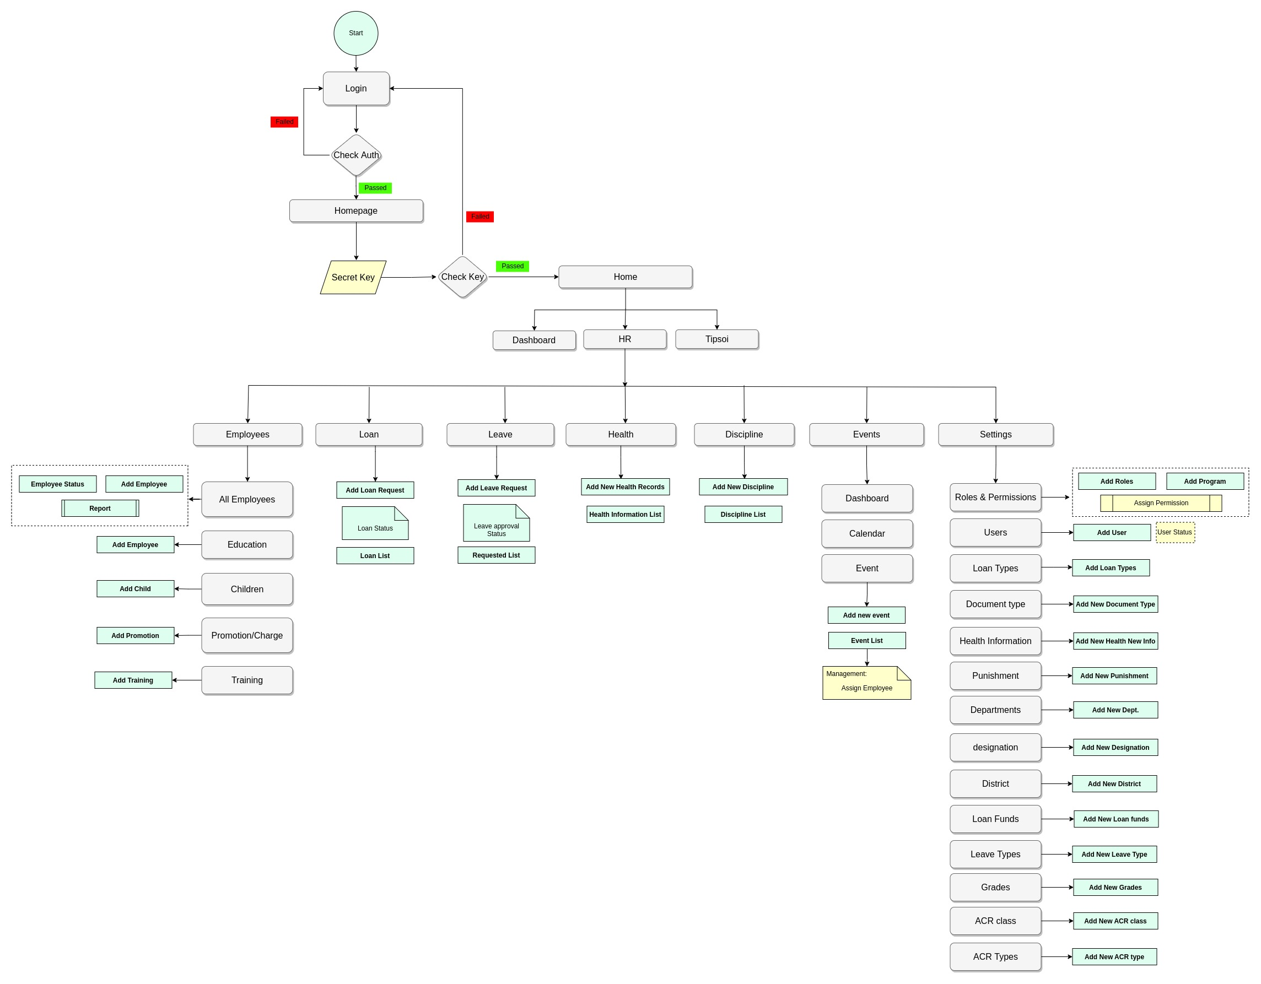

## 4.3 Data Flow Diagram

## 

# Chapter – 5: Testing Documentation

## 5.1 Introduction

The Test Plan is designed to prescribe the scope, approach, resources, and schedule of all testing activities of the HR Management System of BBA. The plan identify the items to be tested, the features to be tested, the types of testing to be performed, the personel responsible for testing, the resources and schedule required to complete testing, and the risks associated with the plan.

## 5.2 Scopes

**1. In scope:**

|  |  |  |
| --- | --- | --- |
| Name | Applicable Roles | Description |
|  |  |  |
|  |  |  |
|  |  |  |
|  |  |  |
|  |  |  |
|  |  |  |

**2. Out scope**

* User Interface (UI)
* Hardware
* System security and performance

## 5.3 Quality Objective

The test objectives are to verify the Functionality of the system IT Management System, the project should focus on testing the IT management operation such as New Requisition, manage products, all product info and maintenance of them to guarantee all these operation can work normally in real business environment.

## 5.4 Testing Methodology

### 5.4.1 Model

* **Waterfall model** – a dynamic approach where each step depends on the previous one, where the developers follow some sequence of steps progressively downwards forwards to achieve the goal. It is like a waterfall approach containing several phases.

### 5.4.2 Strategies

• Tester has access to the full view of code.

• It is known as transparent or glass box testing

• Avoiding errors and wasting time at an early stage

• White box testing contains various tests -

1. Basic Path testing
2. Loop testing
3. Condition testing
4. Memory perspective testing
5. Performance testing

### 5.4.3 Levels

* Integration testing
* System testing
* Cross Browser Compatibility testing
* User Acceptance Test (UAT)
* API testing

### 5.4.4 Test Deliverables

(a) Before Testing

* Test plans document
* Test case document

(b) After Testing

* Test Results/reports
* Defect Report
* Installation/ Test procedures guidelines

### 5.4.5 Tools

|  |  |  |
| --- | --- | --- |
| No. | Resources | Description |
| 1. | Server | Oracle Database Server |
| 2. | Network | LAN line. |
| 3. | Computer | PC and other OS configuration |

## 5.5 Testing web pages with Result

**i. Human Resource**

Test Cases with Result

**Test Scenario 1: Dashboard**

1. Admin Dashboard

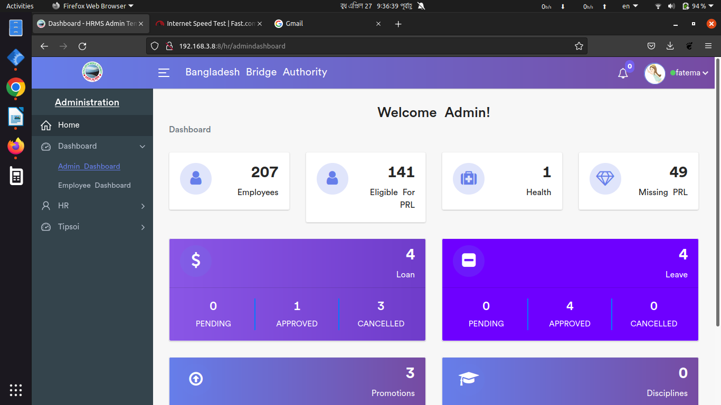

Positive Test Case

|  |  |  |  |  |  |
| --- | --- | --- | --- | --- | --- |
| Case ID | Title | Description | Expected Result | Actual Result | Pass/Fail |
| 1 | Loan | Show details | No error while Displaying loan information | All the information are displayed | P |
| 2 | Leave | Show details | No error while Displaying loan informationAll the information are displayed | All the information are displayed | P |
| 3 | Promotions | Show details | No error while Displaying loan information | All the information are displayed | P |
| 4 | Disciplines | Show details | No error while Displaying loan information | All the information are displayed | P |

Negative Test Case

|  |  |  |  |  |  |
| --- | --- | --- | --- | --- | --- |
| Case ID | Title | Description | Expected Result | Actual Result | Pass/Fail |
| 1 | Loan | No error occurred | Work fine | All information are ok | P |
| 2 | Leave | No error occurred | Work fine | All information are ok | P |
| 3 | Promotions | No error occurred | Work fine | All information are ok | P |
| 4 | Disciplines | No error occurred | Work fine | All information are ok | P |

2. Employee Dashboard

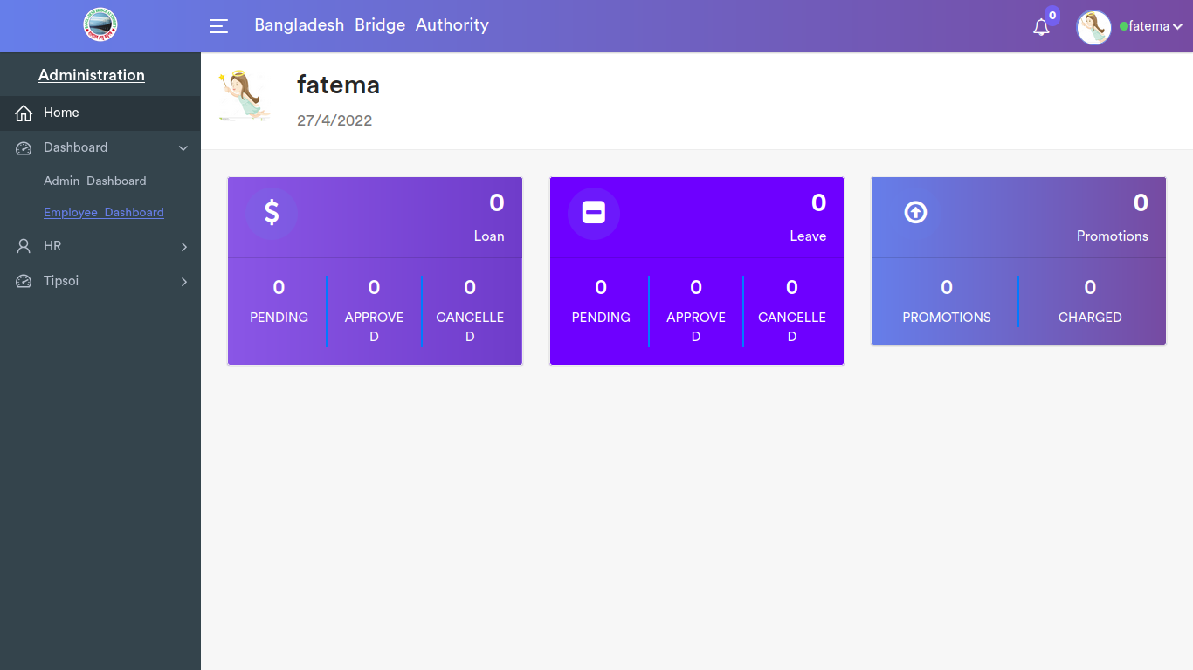

|  |  |  |  |  |  |
| --- | --- | --- | --- | --- | --- |
| Case ID | Title | Description | Expected Result | Actual Result | Pass/Fail |
| 1 | Loan | Show details | No error while Displaying loan information | All the information are displayed | P |
| 2 | Leave | Show details | No error while Displaying loan information | All the information are displayed | P |
| 3 | Promotions | Show details | No error while Displaying loan information | All the information are displayed | P |

Negative Test Case

|  |  |  |  |  |  |
| --- | --- | --- | --- | --- | --- |
| Case ID | Title | Description | Expected Result | Actual Result | Pass/Fail |
| 1 | Loan | No error occurred | Work fine | All information are ok | P |
| 2 | Leave | No error occurred | Work fine | All information are ok | P |
| 3 | Promotions | No error occurred | Work fine | All information are ok | P |

**Test Scenario 2: Human Resource**

1. Employees

i. All employess

*a) Add Employee*

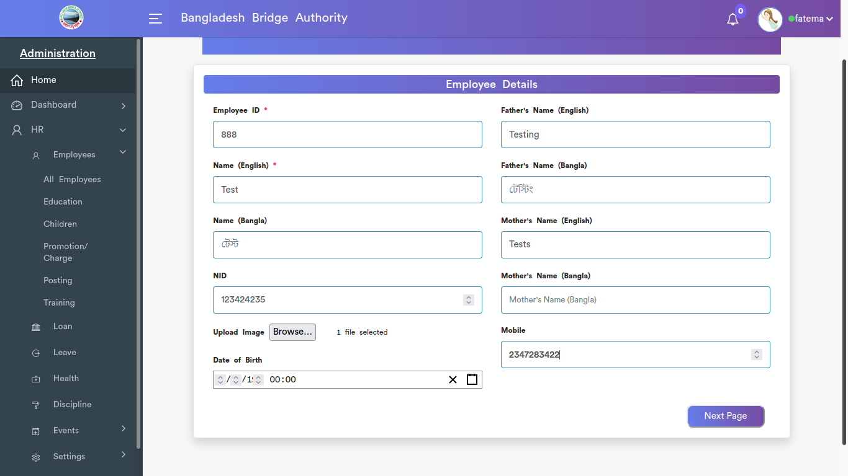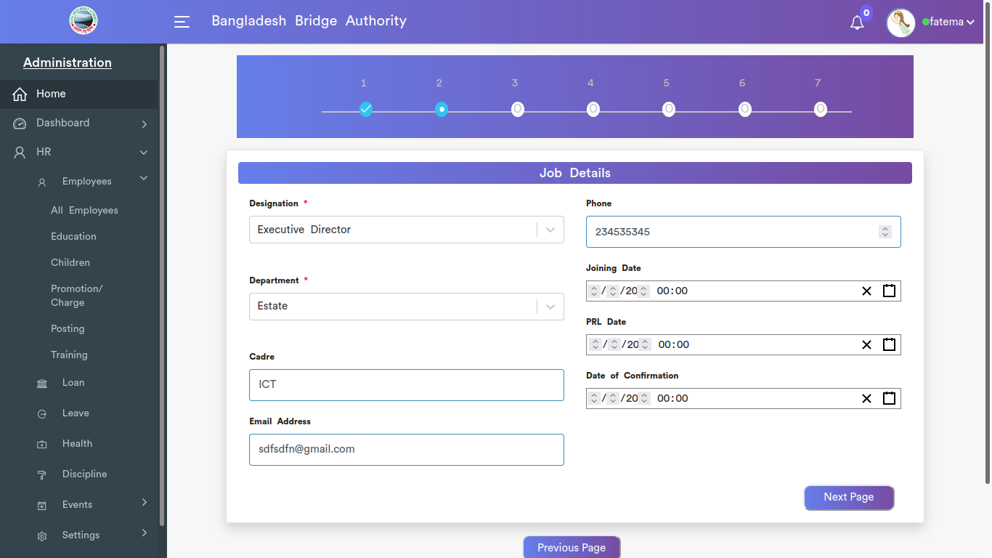

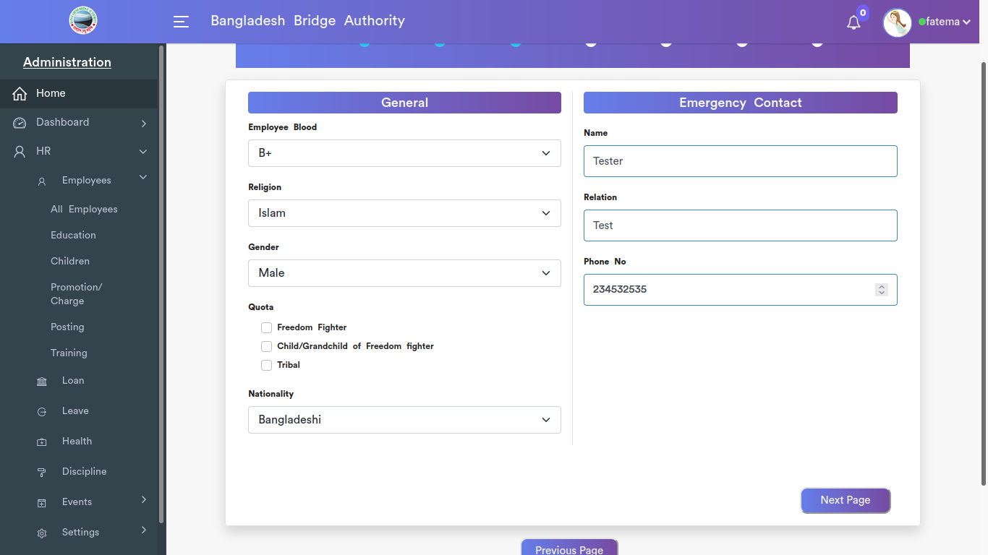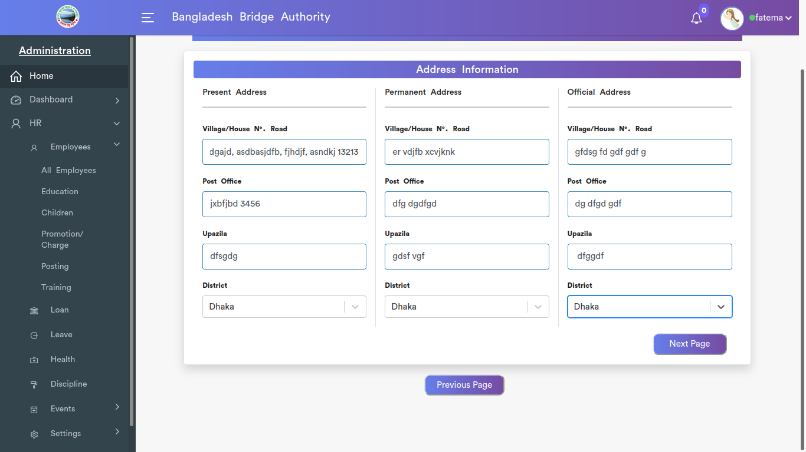

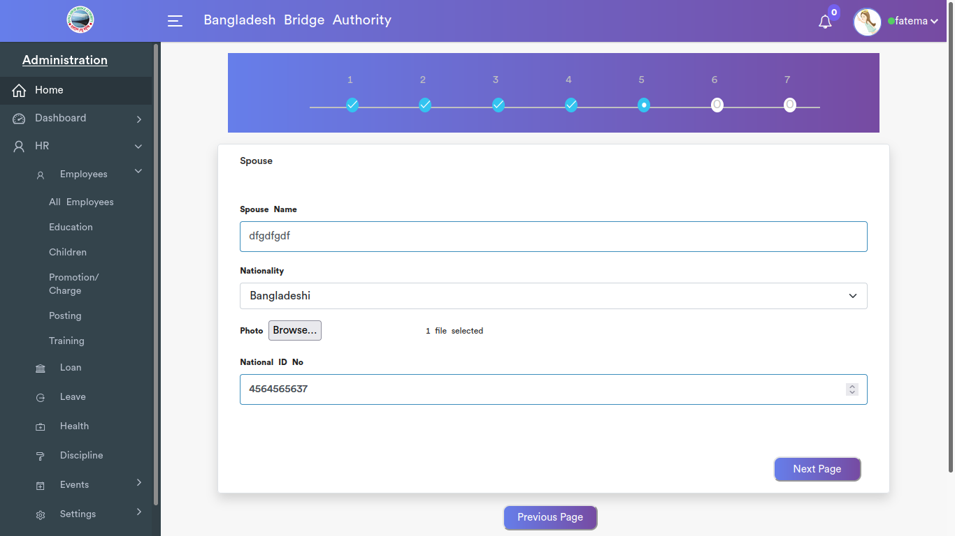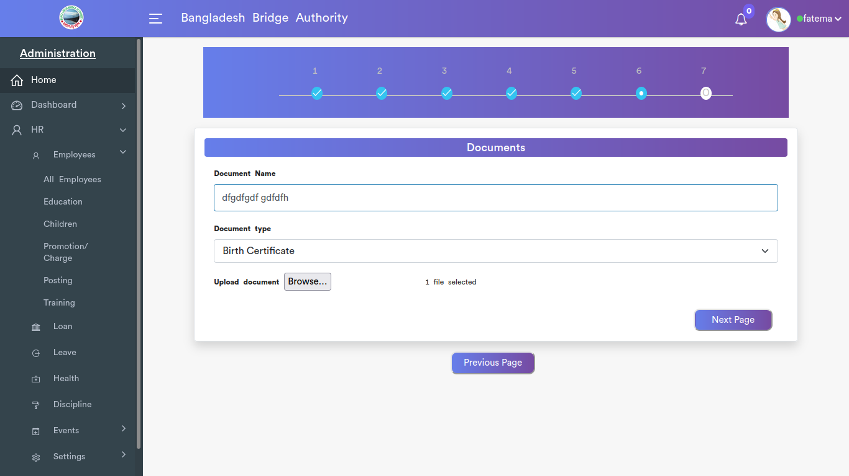

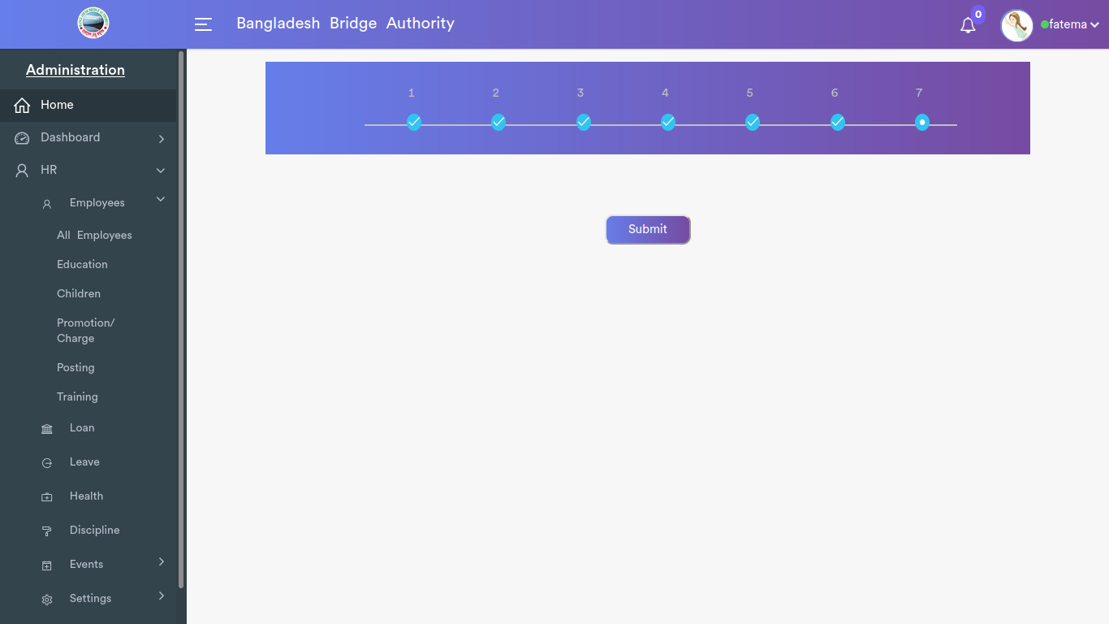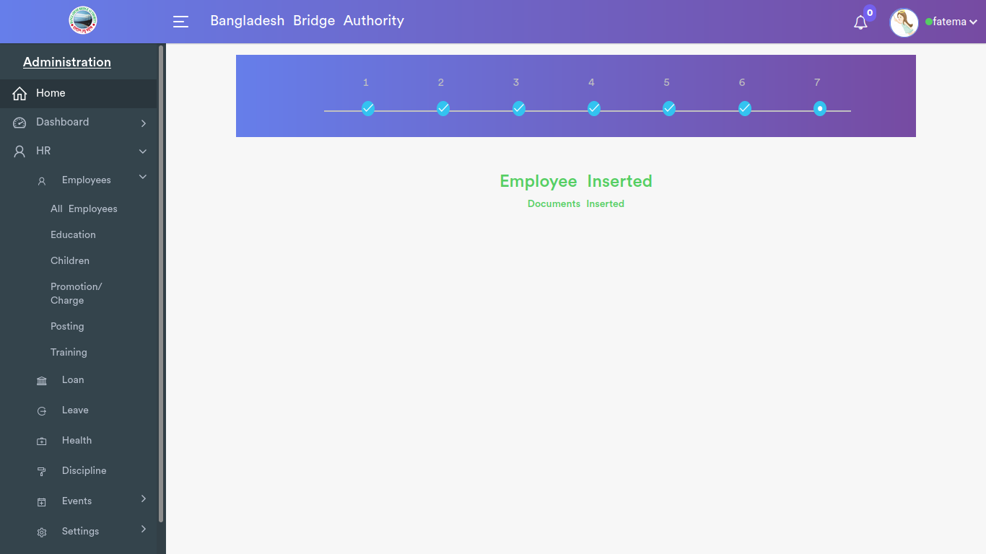

*Positive test case*

|  |  |  |  |  |  |
| --- | --- | --- | --- | --- | --- |
| Case ID | Title | Description | Expected Result | Actual Result | Pass/Fail |
| 1 | Employee Information | 1. Enter unique employee id  2. Enter Employee name in english and bangla  3. Enter NID no.  4. Upload Image  5. Select Date of birth  6. Enter father’s and mother’s name both in english and bangla  7. Enter mobile no.  8. click next page | Going to the next phase | Next page successfully entered | pass |
| 2 | Job Details | 1. Select designation  2. Select Department  3. Enter Cadre  4. Enter Mail address  5. Enter Phone Number  6. Select Joining Date  7. Select LPR date  8. Select confirmation date  9. click next | Going to the next phase | Next page successfully entered | pass |
| 3 | Employee General Information | 1. Select Blood group  2. select Gender  3. Checked Quota  4. Select nationality  5. Emergency contact name  6. Relationship with employee  7. Emergency contact no  8. click next | Data saved successfully | Going to the next page | P |
| 4 | Address Information | 1. Enter village/House no & Rd no  2. Enter post office  3. Enter upozilla  4. select district  5. Fill up all three forms: present, permanent and official address  6. click next | Data saved successfully | Going to the next page | P |
| 5 | Spouse Details | 1. Enter spouse name  2. select nationality  3. spouse’s photo  4. enter nid no | Data saved successfully | Going to the next page | P |
| 6 | Documents | 1. Enter document name  2. Select document type  3. upload document | Data saved successfully | Going to the next page | P |
| 7 | submit | 1. click submit to store the employee information | Data saved successfully | No error is displayed | P |

*Negative Test Case*

|  |  |  |  |  |  |
| --- | --- | --- | --- | --- | --- |
| Case ID | Title | Description | Expected Result | Actual Result | Pass/Fail |
| 1 | Employee information | 1. Enter unique id  2. Name in bangla should be in bangla  3. NID should be verified  4. image should have a specific format  5. DoB should be valid  6. mobile number should be in valid format | Data are valid and ok | No irrelevant data | P |
| 2 | Job details | 1. select designation or not  2. select respective dept or not  3. cadre should be valid  4. mail and phone no should be valid  5. date should be selected and valid   |  |  |  | | --- | --- | --- | |  | No irrelevant data | P | | Data are valid and ok | No irrelevant data | P |
| 3 | Employee General Information | 1. check all the option selected or not  2. Check emergency details entered correctly or not | Data are valid and ok | No irrelevant data | P |
| 4 | Address Information | 1. check the upozilla is under the selected district or not  2. post office should be entered with post code | Data are valid and ok | No irrelevant data | P |
| 5 | Spouse Details | 1. Spouse name should not empty  2. checked photo dimension and format  3. NID verified or not  4. if no spouse click skip button | Data are valid and ok | No irrelevant data | P |
| 6 | Documents | Document name & format should be checked | Data are valid and ok | No irrelevant data | P |
| 7 | submit | submit cancellation or go to the previous page | Successfully stored | No error | P |

b) Employees List

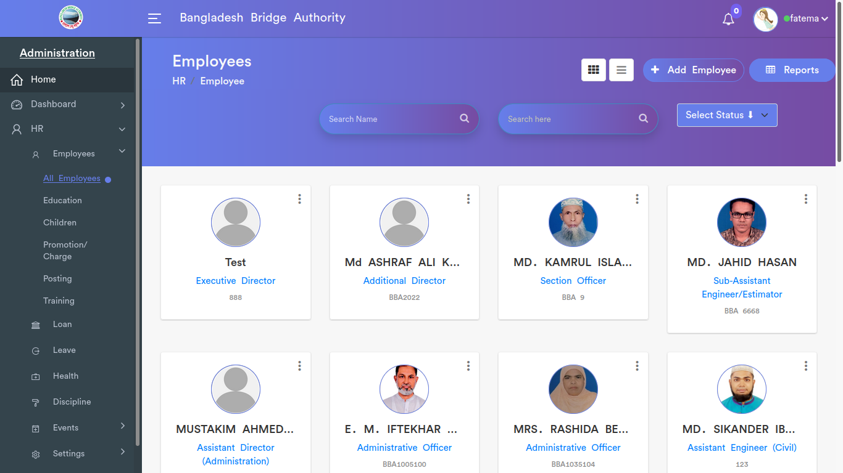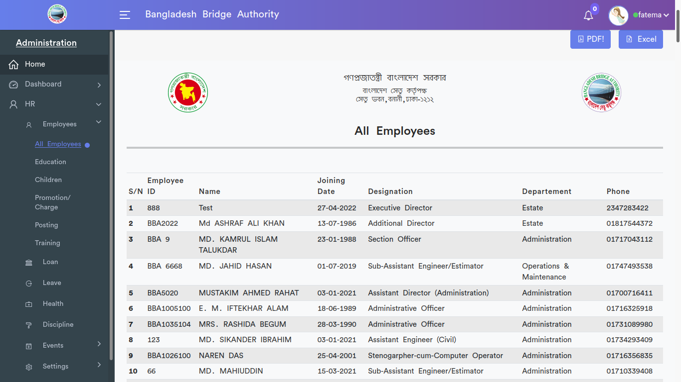

*Positive Test Cases*

|  |  |  |  |  |  |
| --- | --- | --- | --- | --- | --- |
| Case ID | Title | Description | Expected Result | Actual Result | Pass/Fail |
| 1 | Employees | Display the all information list about employee | All the information are present | No missing while displaying | P |
| 2 | Status | Employee status can be changed with enable or disable | Perfectly changed | Everything is ok | P |
| 3 | Report | Report is generated for all employee information | Generated | Show in a list | P |

*Negative Test Cases*

|  |  |  |  |  |  |
| --- | --- | --- | --- | --- | --- |
| Case ID | Title | Description | Expected Result | Actual Result | Pass/Fail |
| 1 | Employees | No information is missing while displaying the employees list | Everything works fine | No error is occurred | P |
| 2 | Status | Status must be changeable | Everything works fine | No error is occurred | P |
| 3 | Report | Report can save and download for both in xcell or pdf format | Everything works fine | No error is occurred | P |

ii. Education

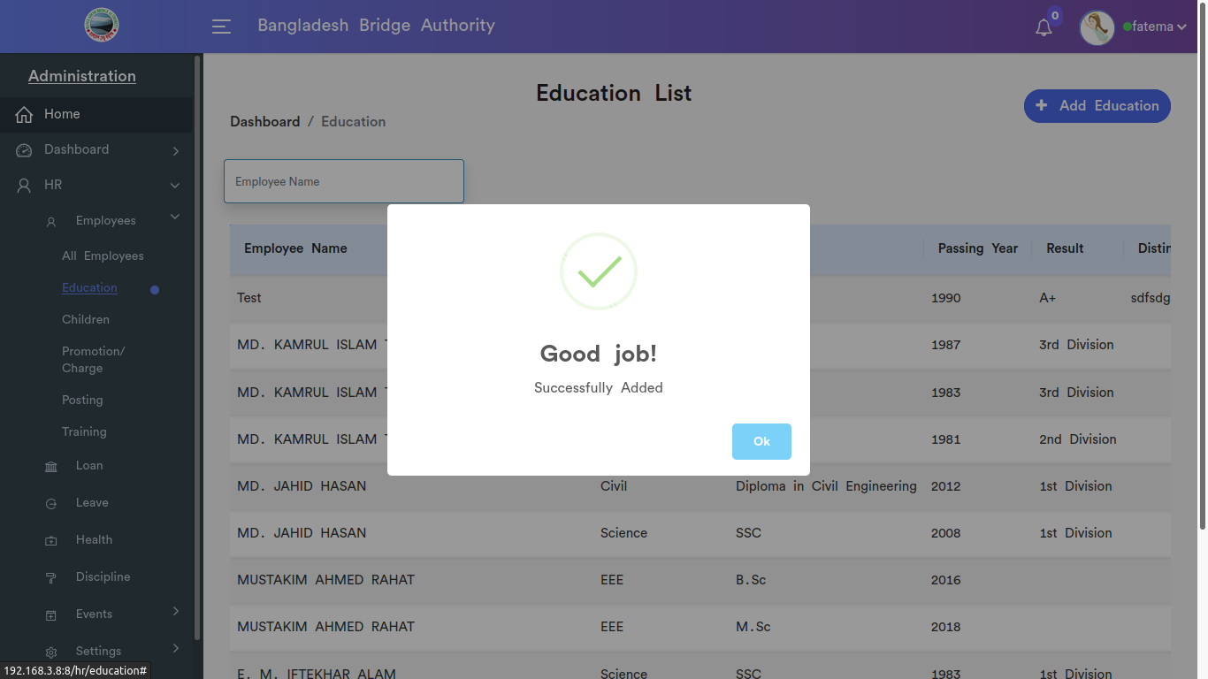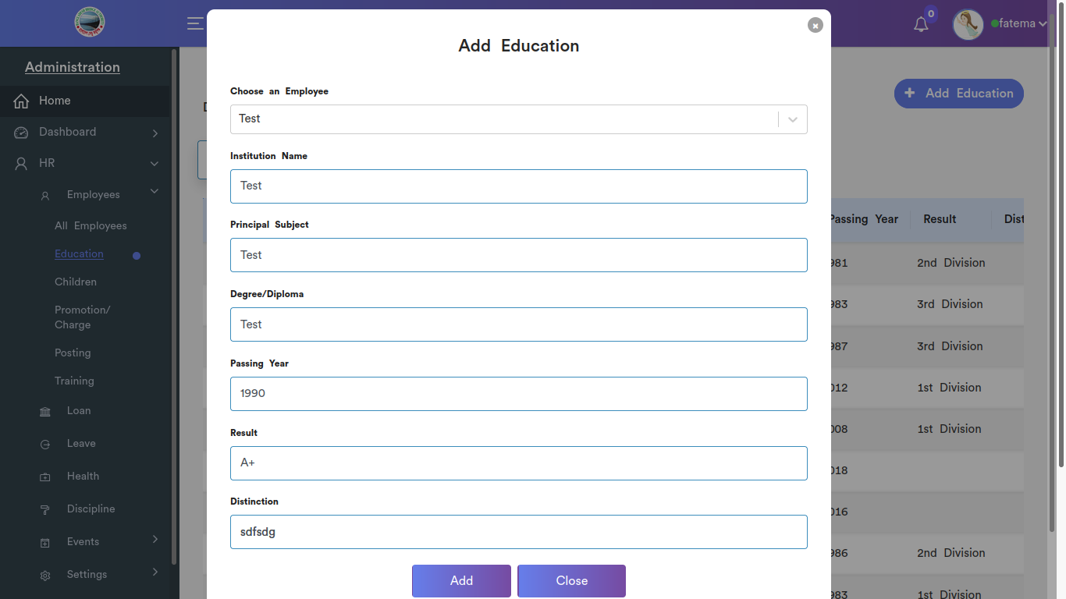

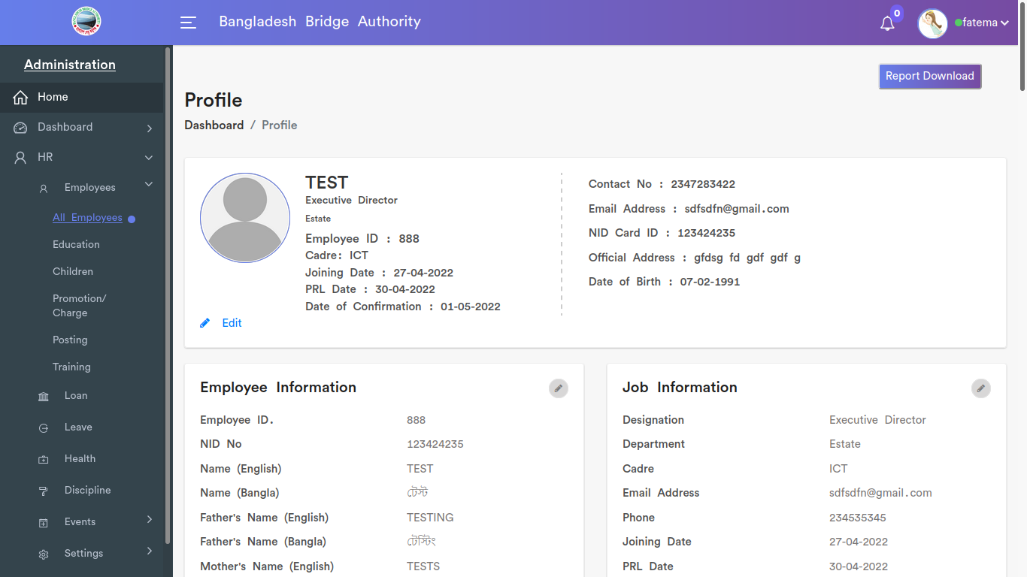

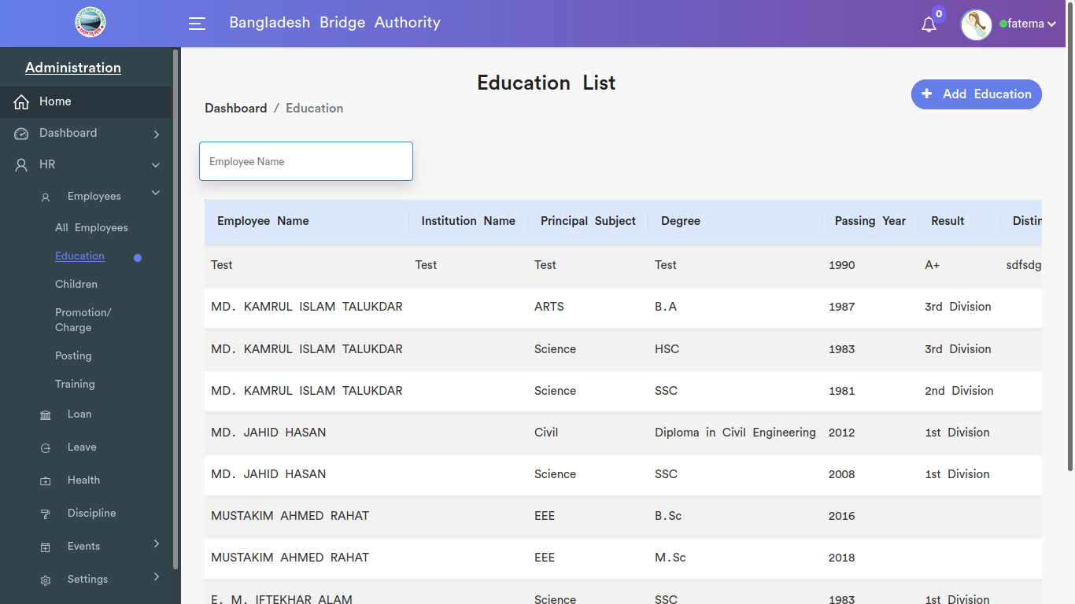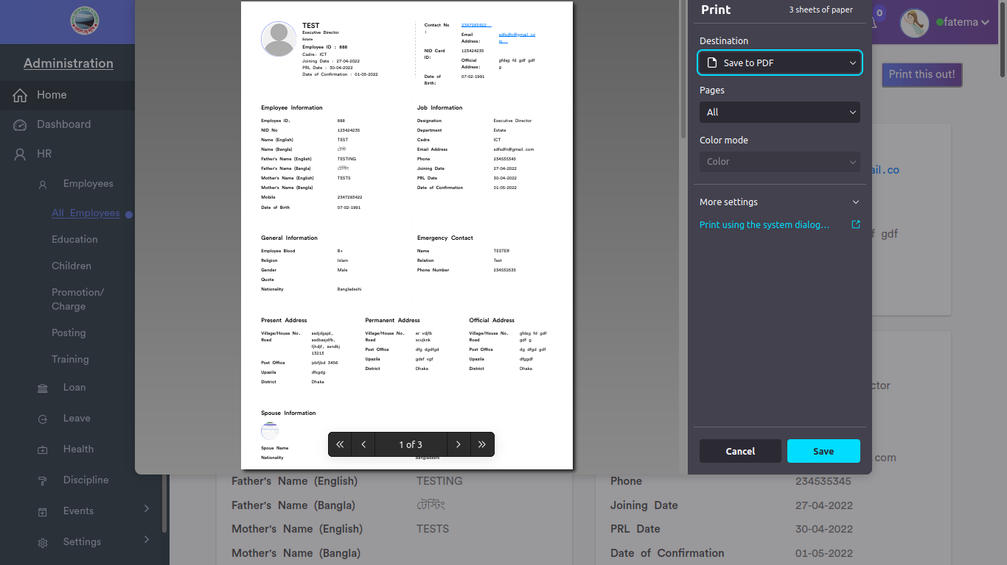

*Positive test case*

|  |  |  |  |  |  |
| --- | --- | --- | --- | --- | --- |
| Case ID | Title | Description | Expected Result | Actual Result | Pass/Fail |
| 1 | Add Education | 1. Enter/ Select an employee  2. Enter Institution Name  3. Enter Principal Subject  4. Enter Degree/Diploma  5. Enter Passing Year  6. Enter Result  7. Enter Distinction  8. click add or skip | Data saved successfully | No error is displayed | P |
| 2 | Education List | 1. Enter Employee name to search Educational Qualification  2. Click Report Download to download an employee report | All the information are present | No missing while displaying | P |

*Negative Test Case*

|  |  |  |  |  |  |
| --- | --- | --- | --- | --- | --- |
| Case ID | Title | Description | Expected Result | Actual Result | Pass/Fail |
| 1 | Add Education | 1. employee should be selected  2. Passing year, subject, degree should be valid | Data are valid and ok | No irrelevant data | P |
| 2 | Education List | 1. Report is generated into pdf or not | Operation is perfectly done | No error occurred | P |

iii. Children

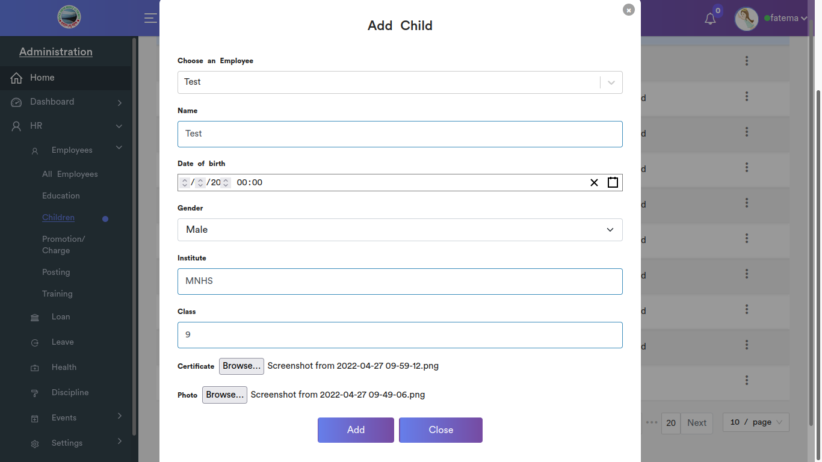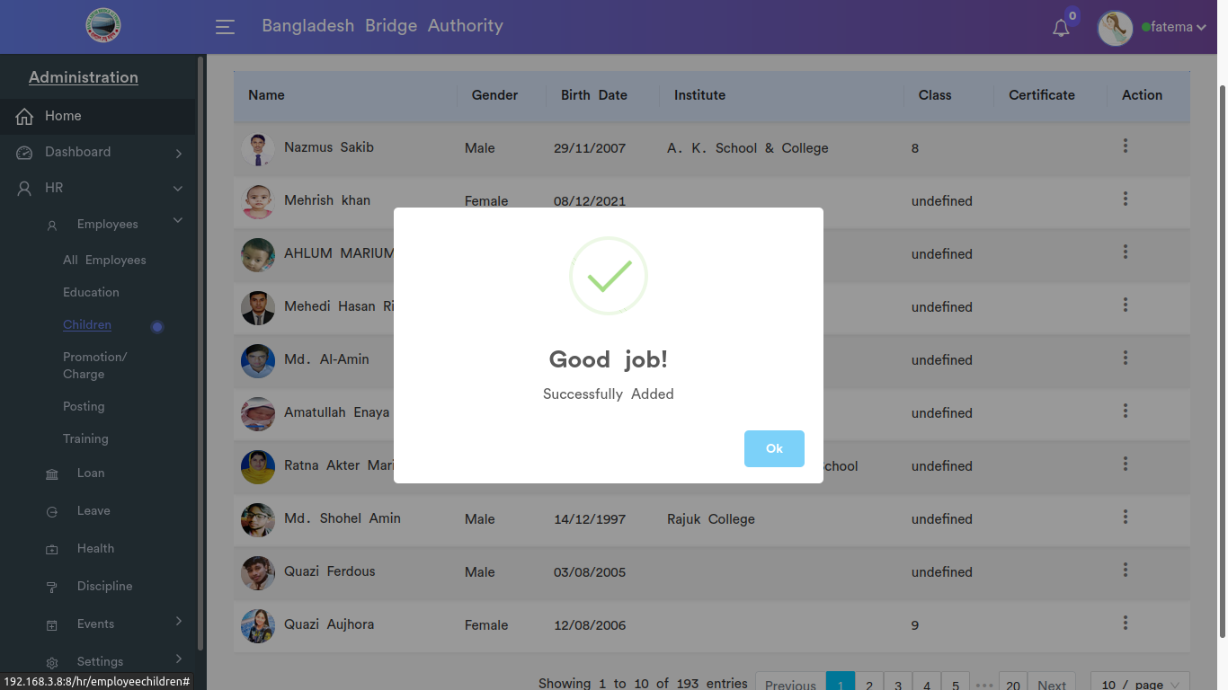

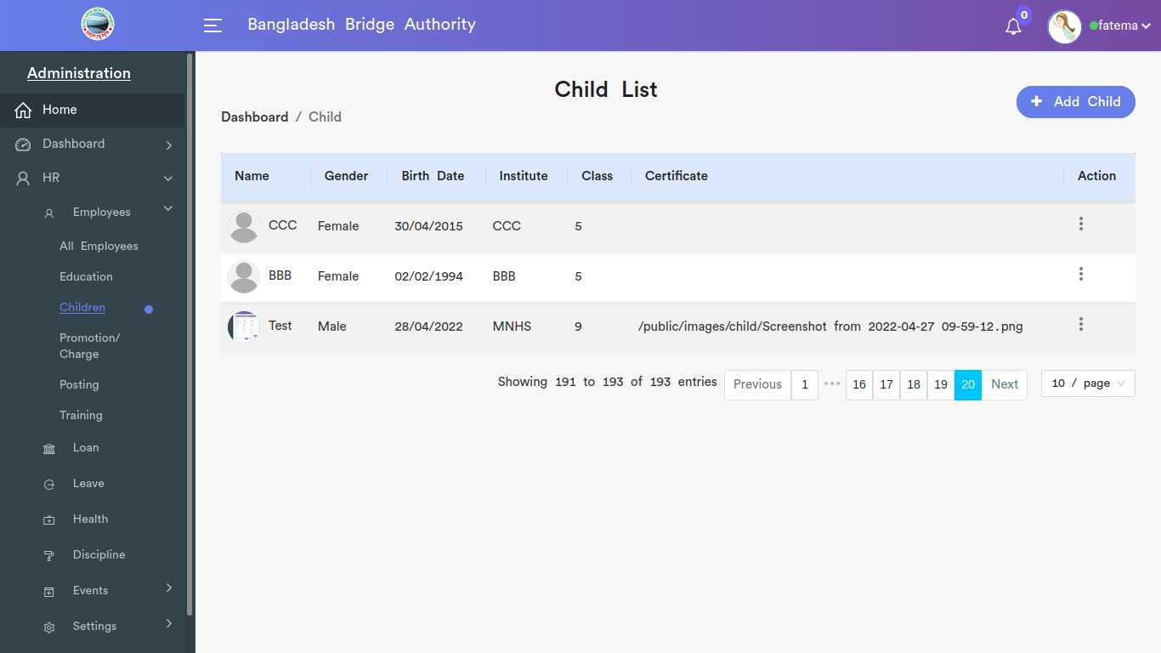

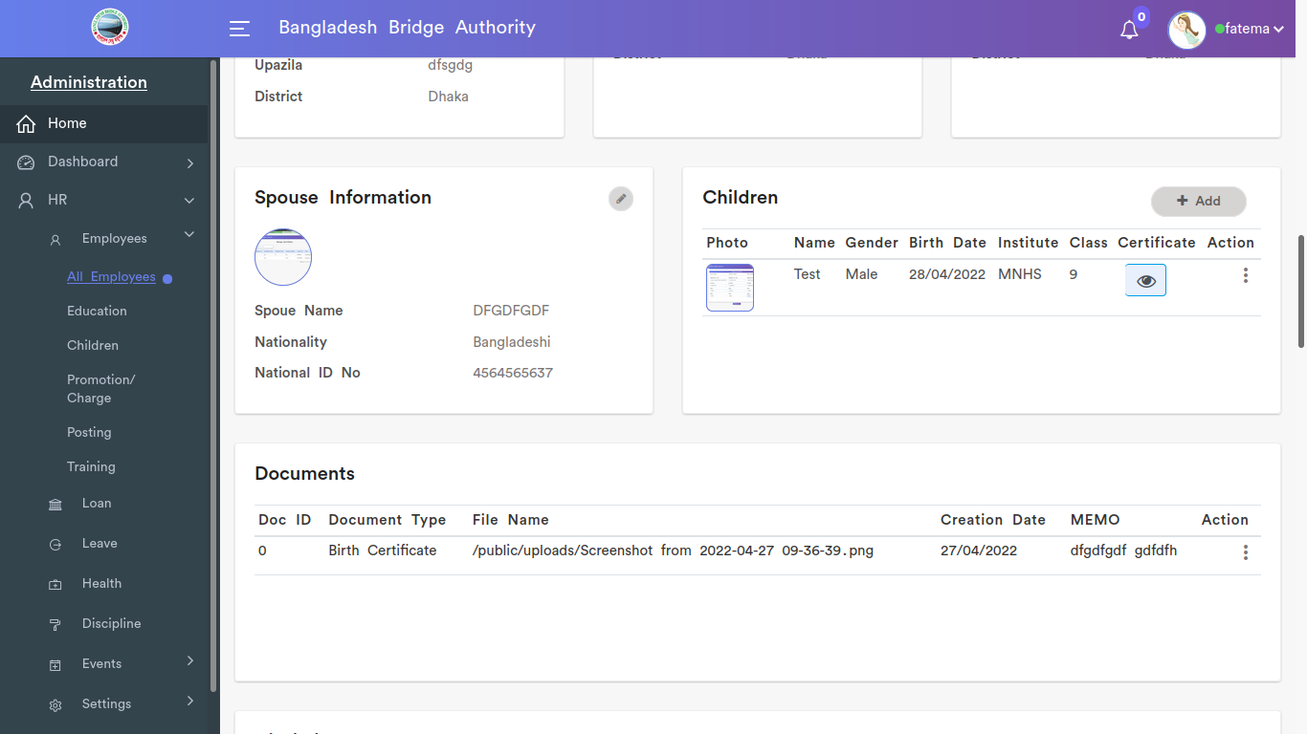

*Positive test case*

|  |  |  |  |  |  |
| --- | --- | --- | --- | --- | --- |
| Case ID | Title | Description | Expected Result | Actual Result | Pass/Fail |
| 1 | Add child | 1. Select employee  2. enter child name  3. select DoB  4. select gender  5. Enter Institute name  6. upload certificate and photo  7. click add or skip | Data saved successfully | No error is displayed | P |
| 2 | Child list | 1. click action to view reported  2. click report download to download children report | All the information are present | No missing while displaying | P |

*Negative Test Case*

|  |  |  |  |  |  |
| --- | --- | --- | --- | --- | --- |
| Case ID | Title | Description | Expected Result | Actual Result | Pass/Fail |
| 1 | Add child | 1. employee should be selected  2. select and enter all the contents  3. photo and other documents should be on specific format | Data are valid and ok | No irrelevant data | P |
| 2 | Child list | Report should be on document format | Operation is perfectly done | No error occurred | P |

iv. Promotion/Charge

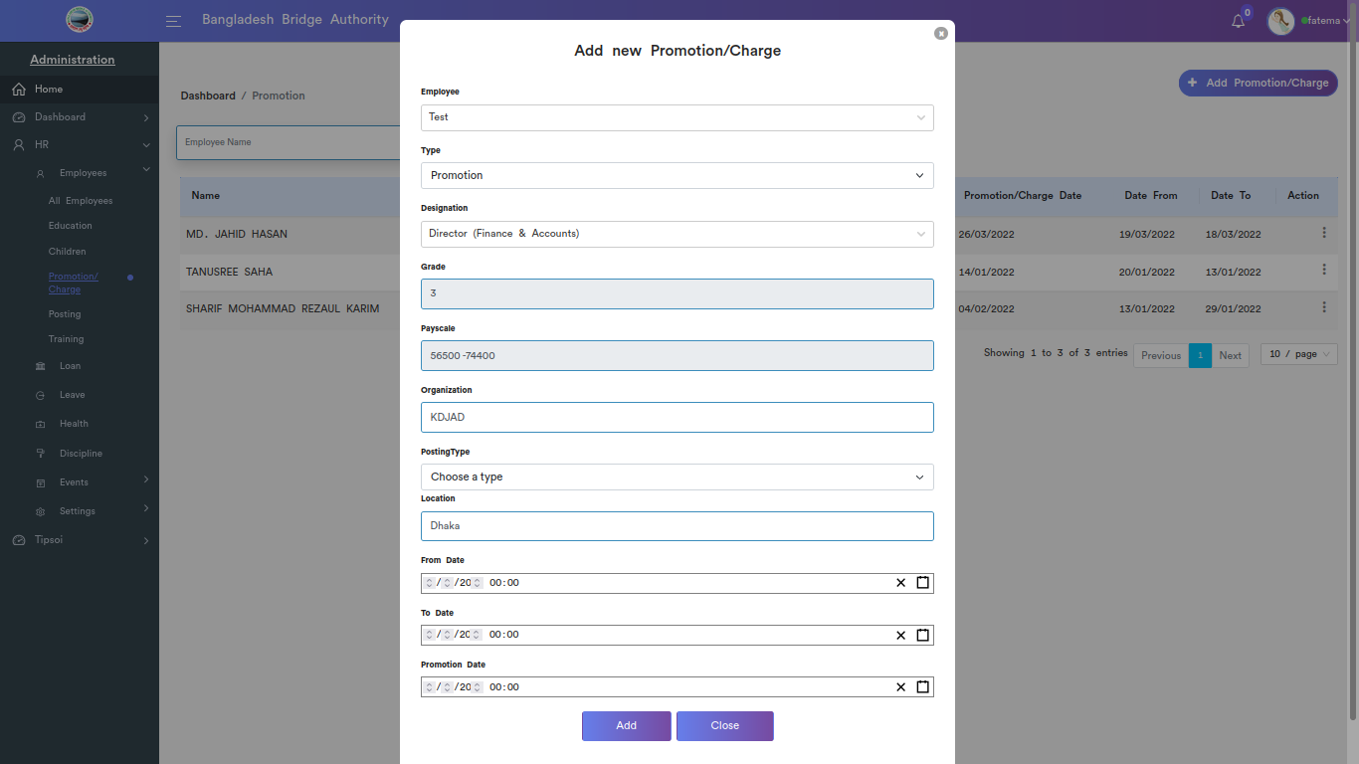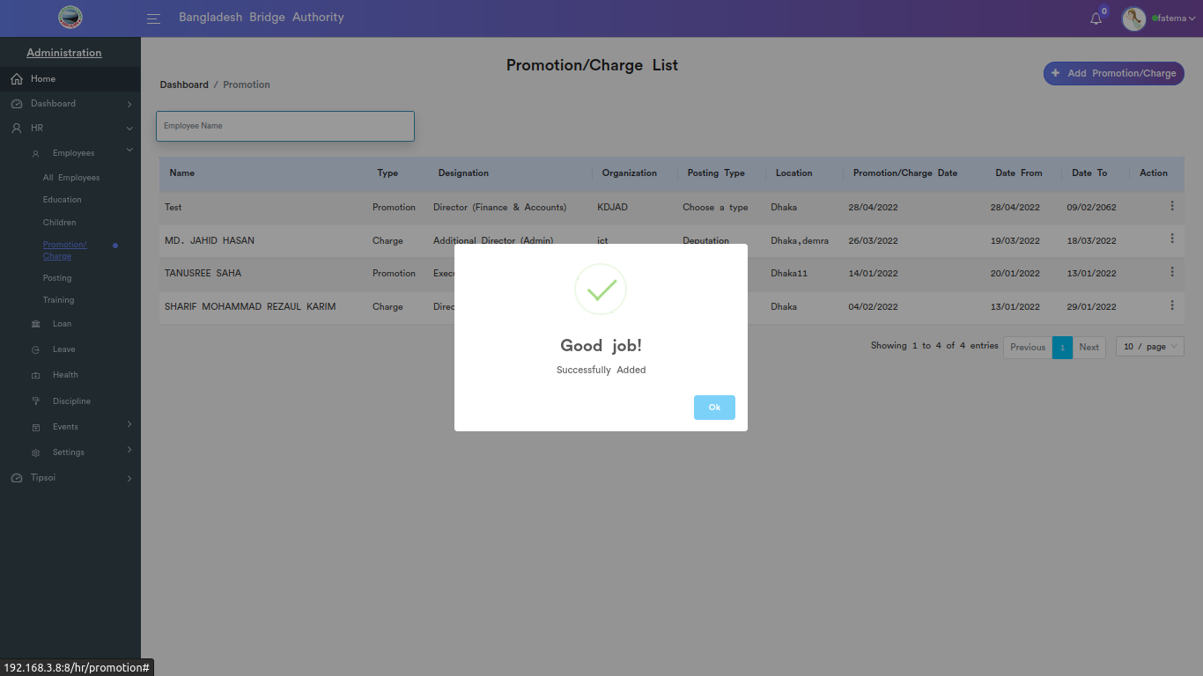

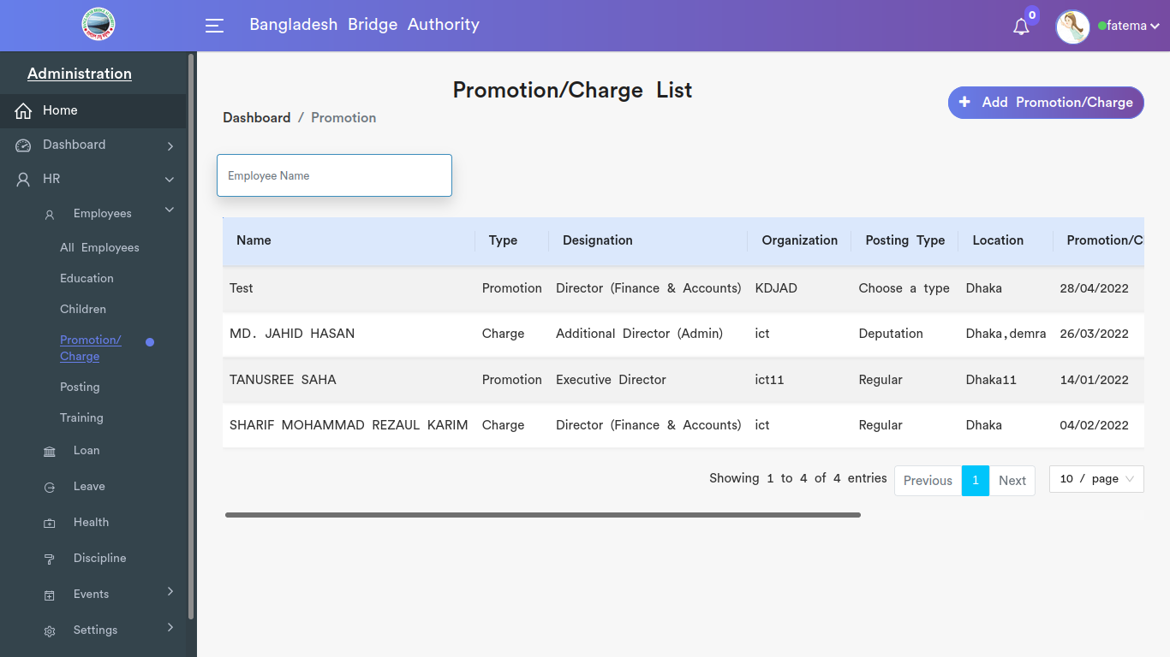

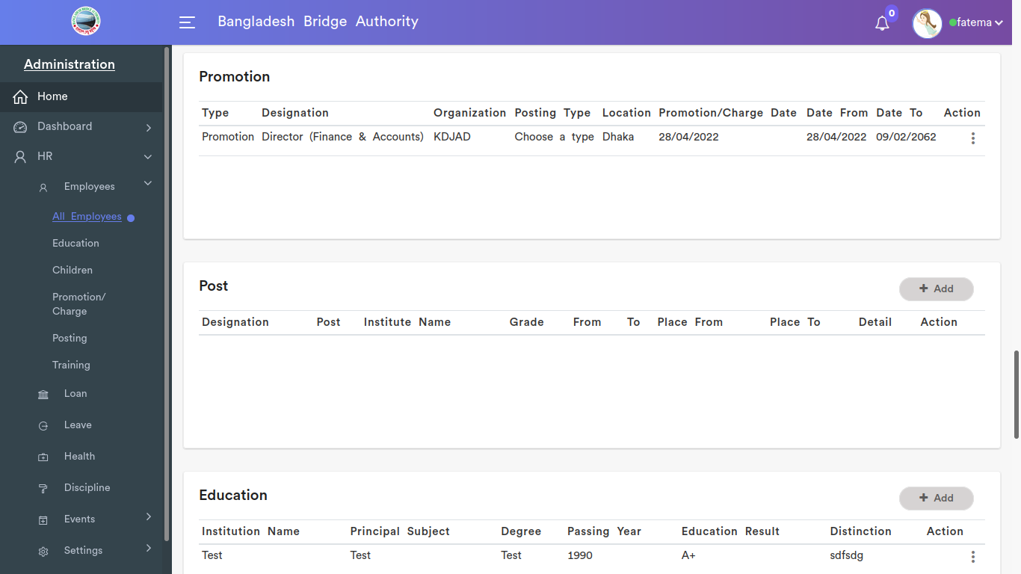

*Positive test case*

|  |  |  |  |  |  |
| --- | --- | --- | --- | --- | --- |
| Case ID | Title | Description | Expected Result | Actual Result | Pass/Fail |
| 1 | Add new Promotion / Charge | 1. Select Employee  2. choose a specific type  3. select employee’s designation  4. Enter Organization  5. Select Posting type  6. Enter Location  7. Select from, to, and promotion date  8. click add or skip | Data saved successfully | No error is displayed | P |
| 2 | Promotion / Charge list | 1. enter search to find specific employee promotion/charge  2. click edit to update promotion/charge information  3. click delete to delete that specific employee promotion/charge | Action button does the specific operation | Works fine & displayed | P |

*Negative Test Case*

|  |  |  |  |  |  |
| --- | --- | --- | --- | --- | --- |
| Case ID | Title | Description | Expected Result | Actual Result | Pass/Fail |
| 1 | Add new Promotion / Charge | 1. employee and his designation selected or not  2. ensure entrance of organization and location  3. ensure valid date | Data are valid and ok | No irrelevant data | P |
| 2 | Promotion / Charge list | report in pdf or edit information | Operation is perfectly done | No error occurred | P |

v. Posting

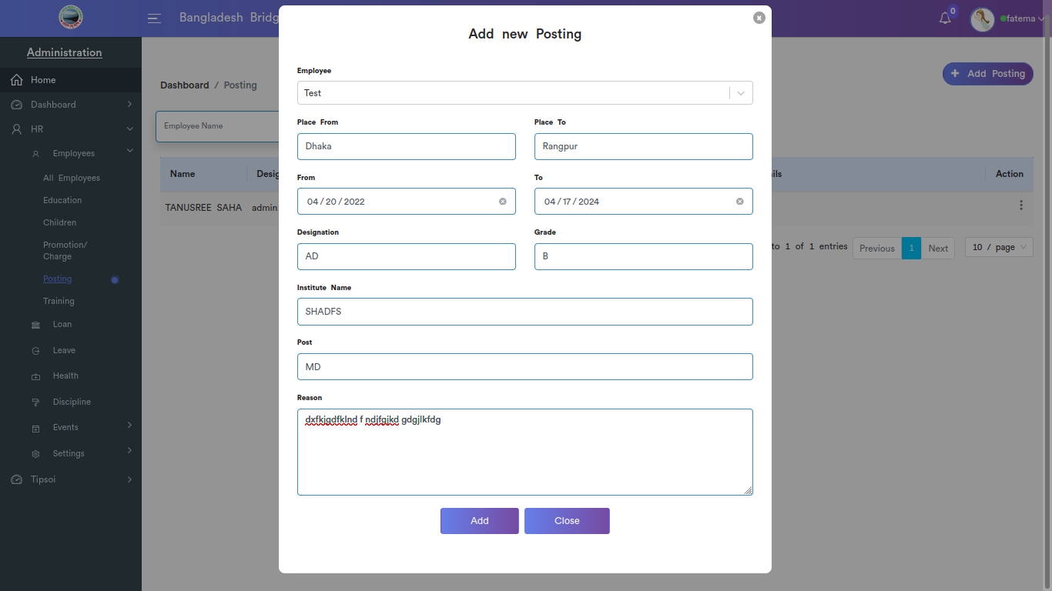



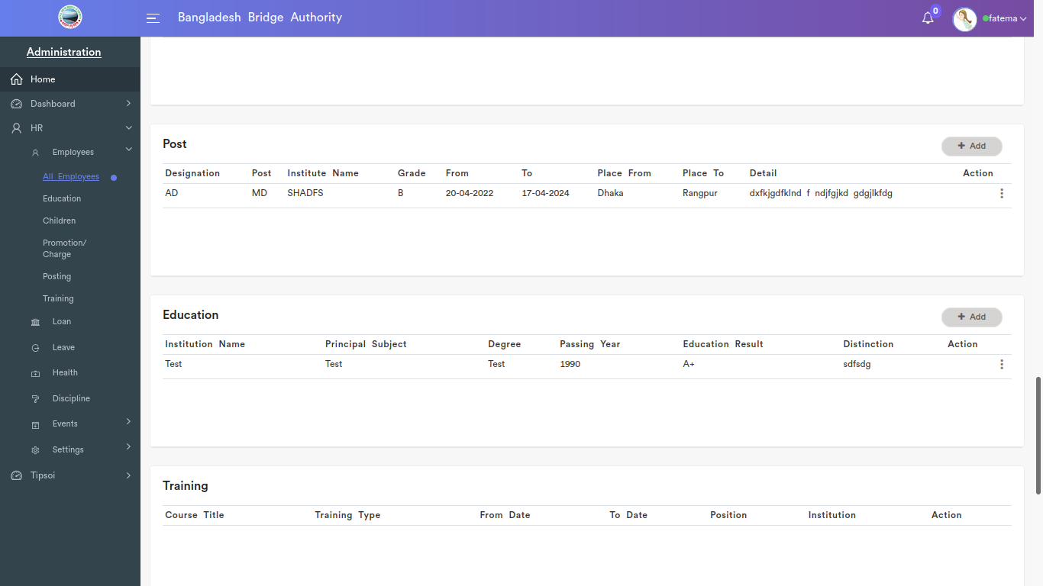

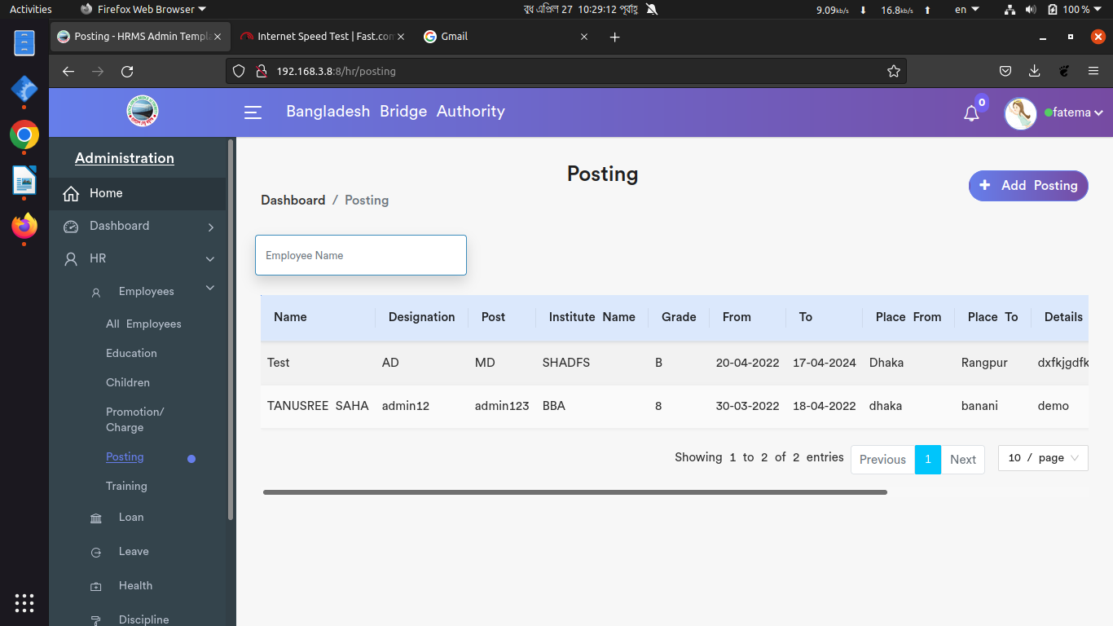

*Positive test case*

|  |  |  |  |  |  |
| --- | --- | --- | --- | --- | --- |
| Case ID | Title | Description | Expected Result | Actual Result | Pass/Fail |
| 1 | Add new Posting | 1. Select employee  2. Enter place from and to  3. Select from date & to date  4. Enter designation, grade, institute name, post name & posting reason  5. Click add | Data saved successfully | No error is displayed | P |
| 2 | Posting List | 1. enter search to find specific employee posting  2. click edit to update posting information  3. click delete to delete that specific employee posting | Action button does the specific operation | Works fine & displayed | P |

*Negative Test Case*

|  |  |  |  |  |  |
| --- | --- | --- | --- | --- | --- |
| Case ID | Title | Description | Expected Result | Actual Result | Pass/Fail |
| 1 | Add new Posting | 1. employee and his designation selected or not  2. ensure entrance of organization and location  3. ensure valid date | Data are valid and ok | No irrelevant data | P |
| 2 | Posting List | report in pdf or edit information | Operation is perfectly done | No error occurred | P |

vi. Training

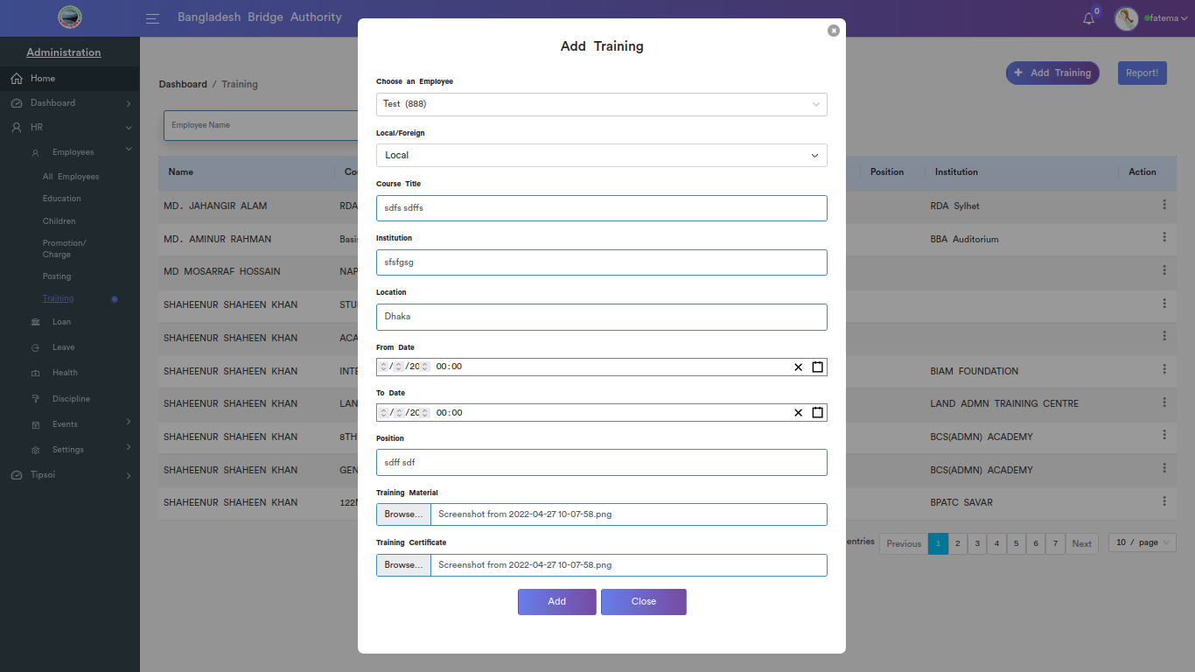

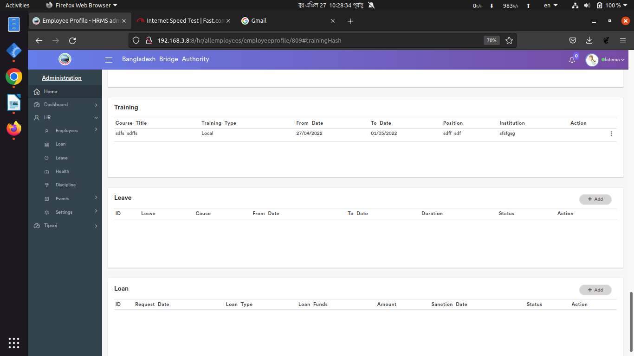

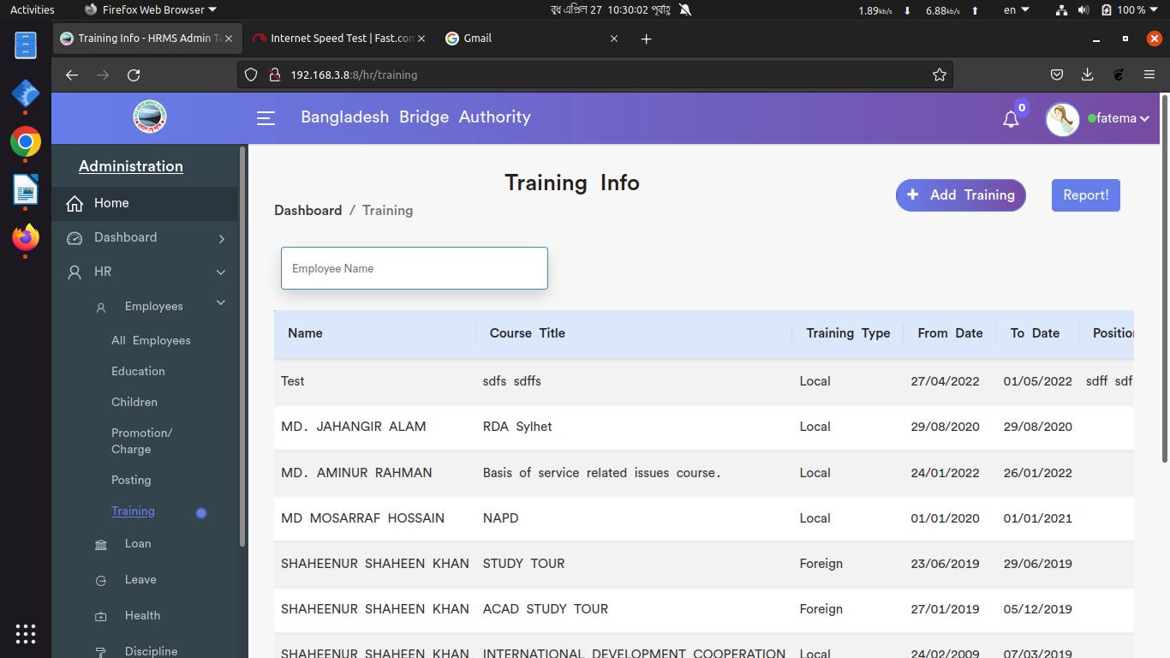

*Positive test case*

|  |  |  |  |  |  |
| --- | --- | --- | --- | --- | --- |
| Case ID | Title | Description | Expected Result | Actual Result | Pass/Fail |
| 1 | Add Training | 1. Select employee  2. select area  3. Enter course title  4. Enter institution  5. Enter location  6. Enter from date & to date  7. Enter position  8. upload training material and certificate information  9. click add or skip | Data saved successfully | No error is displayed | P |
| 2 | Training details | 1. click search to find a specific trainee  2. click edit to update trainee data and generate a reported  3. click delete to delete trainee information | Action button does the specific operation | Works fine & displayed | P |

*Negative Test Case*

|  |  |  |  |  |  |
| --- | --- | --- | --- | --- | --- |
| Case ID | Title | Description | Expected Result | Actual Result | Pass/Fail |
| 1 | Add Training | 1. employee name, region type should be selected  2. blank space should be completed with appropriate value  3. valid date  4. documents should be on specific format | Data are valid and ok | No irrelevant data | P |
| 2 | Training details | Report should be generated on a specific format | Operation is perfectly done | No error occurred | P |

2. Loan

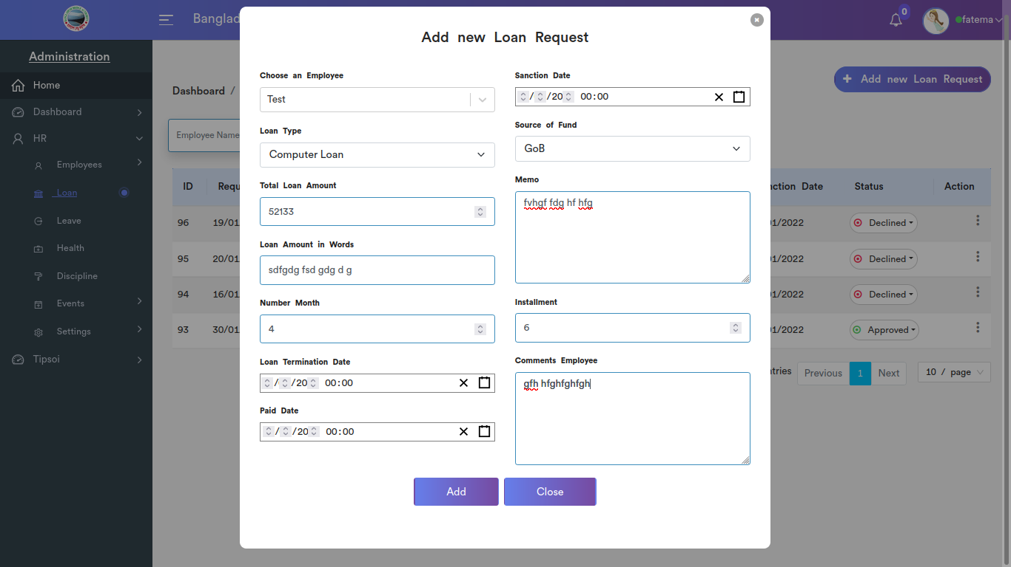

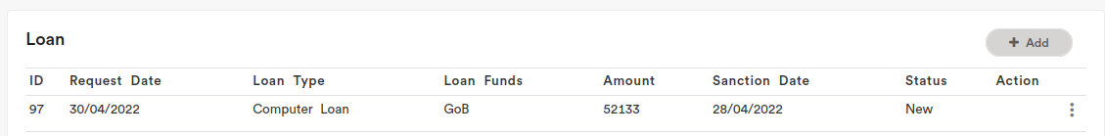

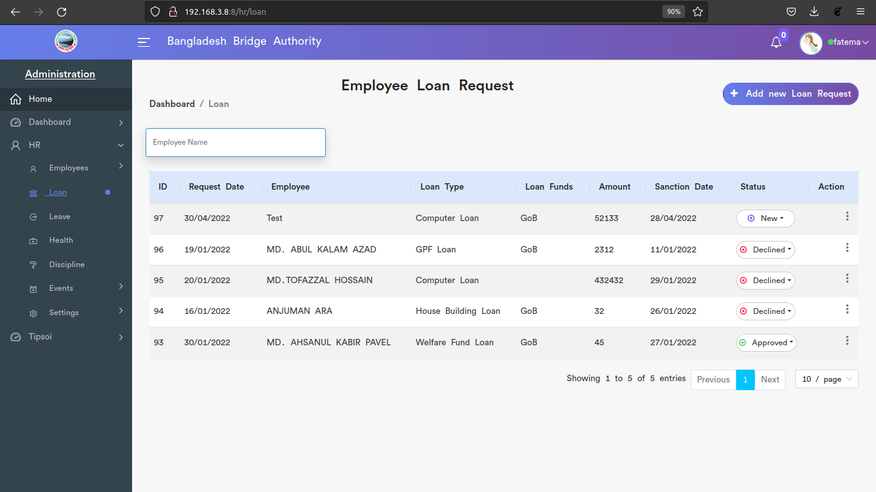

*Positive test case*

|  |  |  |  |  |  |
| --- | --- | --- | --- | --- | --- |
| Case ID | Title | Description | Expected Result | Actual Result | Pass/Fail |
| 1 | Add new loan request | 1. select employee  2. select loan type  3. enter loan amount  4. enter loan amount in words  5. enter month in number  6. enter loan termination, paid, & sanction date  7. select source of fund  8. enter memo, installment, comments details  9. click add or skip | Data saved successfully | No error is displayed | P |
| 2 | Employee Loan Request | 1. click search and type a employee name to find his/her loan request  2. click edit to update loan information and generate a reported  3. click delete to delete trainee information | Action button does the specific operation | Works fine & displayed | P |

*Negative Test Case*

|  |  |  |  |  |  |
| --- | --- | --- | --- | --- | --- |
| Case ID | Title | Description | Expected Result | Actual Result | Pass/Fail |
| 1 | Add new loan request | 1. Employee, loan type, source of funds should be selected  2. total money and amount in words should be the same  3. loan term, paid, sanction date should be valid  4. Memo, installment, comments employee should be in text format | Data are valid and ok | No irrelevant data | P |
| 2 | Employee Loan Request | Report should be editable and can be generated in pdf format | Operation is perfectly done | No error occurred | P |

3. Leave

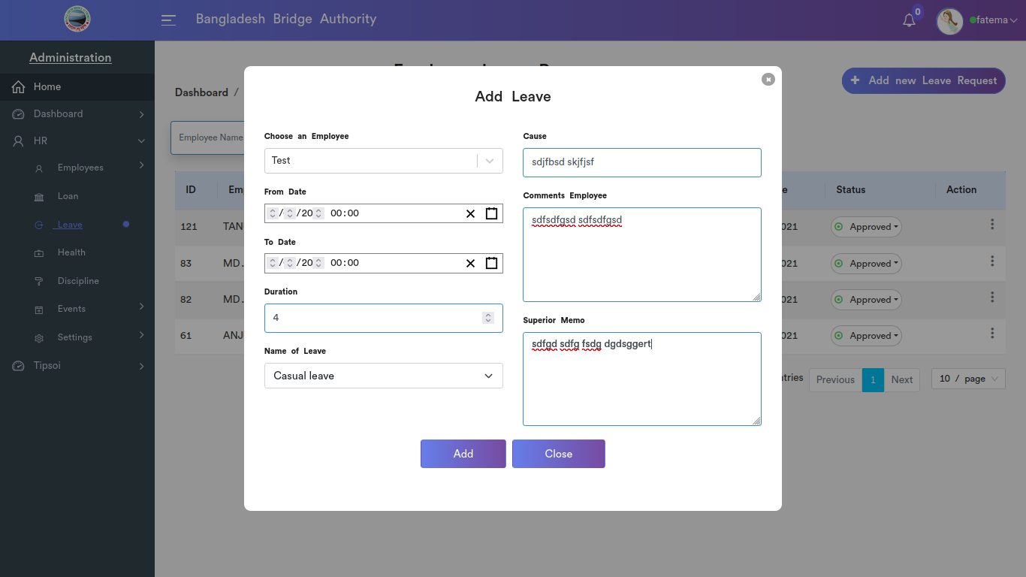



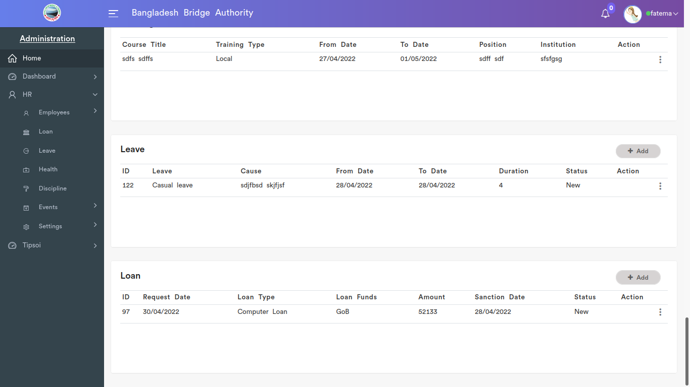

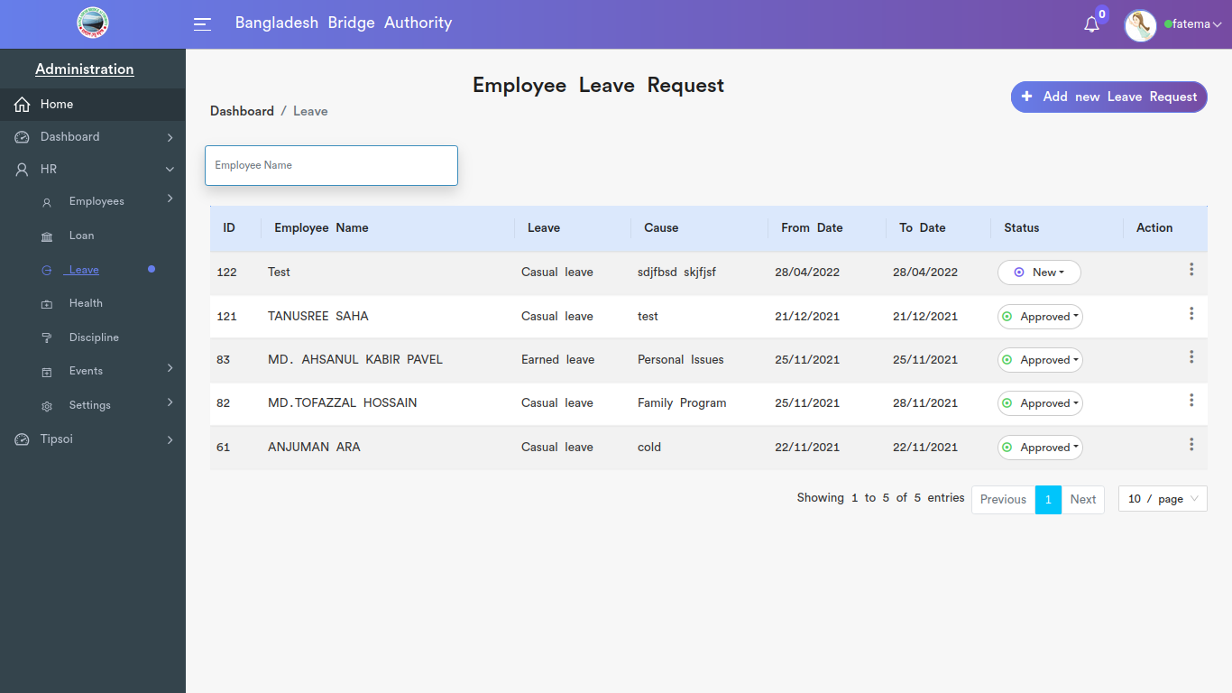

*Positive test case*

|  |  |  |  |  |  |
| --- | --- | --- | --- | --- | --- |
| Case ID | Title | Description | Expected Result | Actual Result | Pass/Fail |
| 1 | Add leave | 1. select employee  2. select form date and to date  3. enter duration  4. select leave types  5. write cause  6. write comments employee and superior memo  7. click add or skip | Data saved successfully | No error is displayed | P |
| 2 | Employee leave request | 1. click search and type a employee name to find his/her leave request  2. click edit to update leave information and generate a reported  3. click delete to delete leave information | Action button does the specific operation | Works fine & displayed | P |

*Negative Test Case*

|  |  |  |  |  |  |
| --- | --- | --- | --- | --- | --- |
| Case ID | Title | Description | Expected Result | Actual Result | Pass/Fail |
| 1 | Add leave | 1. employee leave and from date, to date should be selected on valid format  2. Duration, cause should be filled up  3. comments and memo should be in text format | Data are valid and ok | No irrelevant data | P |
| 2 | Employee leave request | 1. leave request date can be editable  2. Report should be editable and can be generated in pdf format | Operation is perfectly done | No error occurred | P |

4. Health

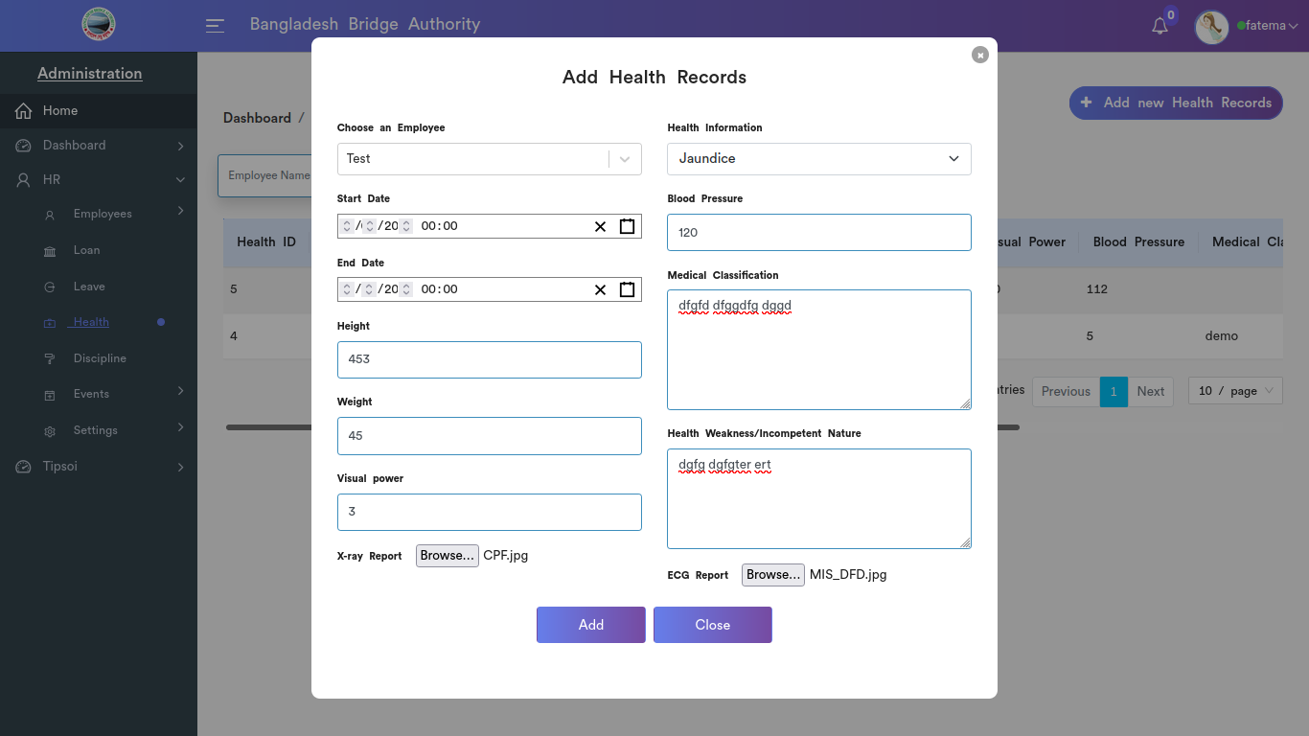

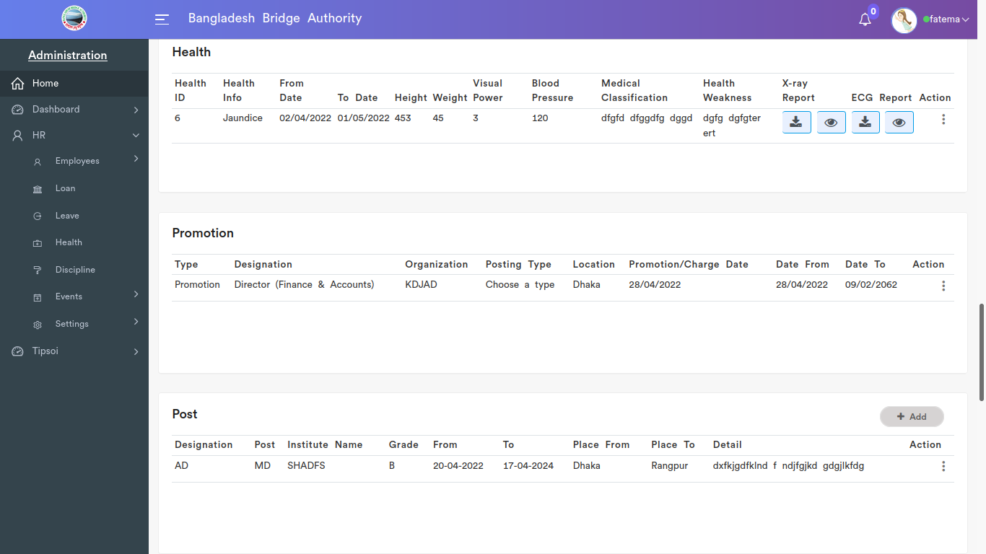

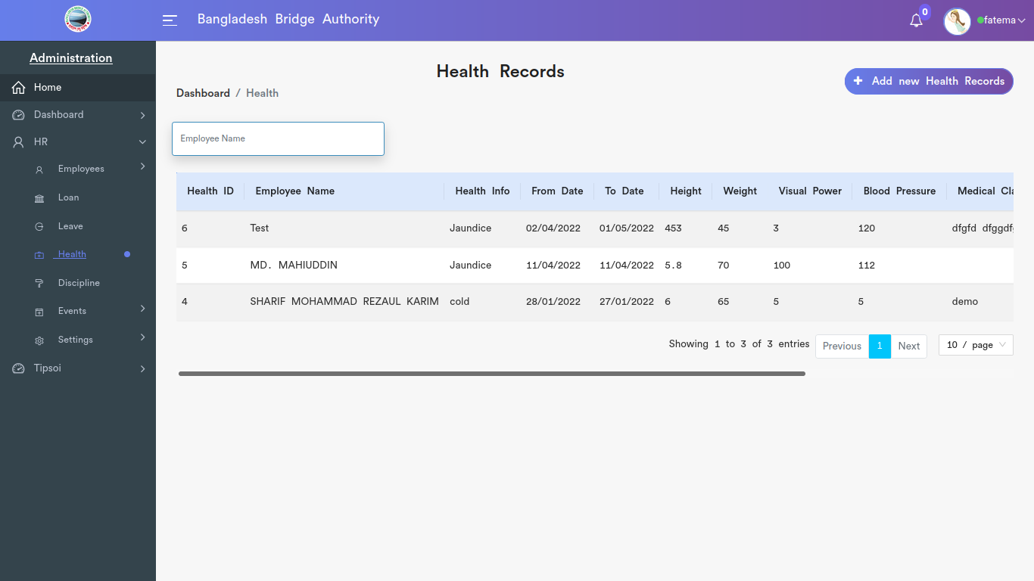

Positive Test Case

|  |  |  |  |  |  |
| --- | --- | --- | --- | --- | --- |
| Case ID | Title | Description | Expected Result | Actual Result | Pass/Fail |
| 1 | Add health records | 1. select employee  2. select start date and end date  3. enter height, weight and visual power  4. upload xray report  5. select health information  6. enter blood pressure  7. describe medical classification and health weakness  8. upload ECG report  9. click add or skip | Data saved successfully | No error is displayed | P |
| 2 | Health Information | 1. click search and type a employee name to find his/her health information  2. click edit to update health information and generate a reported  3. click delete to delete health information | Action button does the specific operation | Works fine & displayed | P |

*Negative Test Case*

|  |  |  |  |  |  |
| --- | --- | --- | --- | --- | --- |
| Case ID | Title | Description | Expected Result | Actual Result | Pass/Fail |
| 1 | Add health records | 1. employee, date, health information should be selected  2. date should be valid  3. uploading report should have specific format  4. blank should be filled | Data are valid and ok | No irrelevant data | P |
| 2 | Health Information | Can be deleted successfully and edit button can generate report and make a copy of document of that report | Operation is perfectly done | No error occurred | P |

**5. Disciplines**

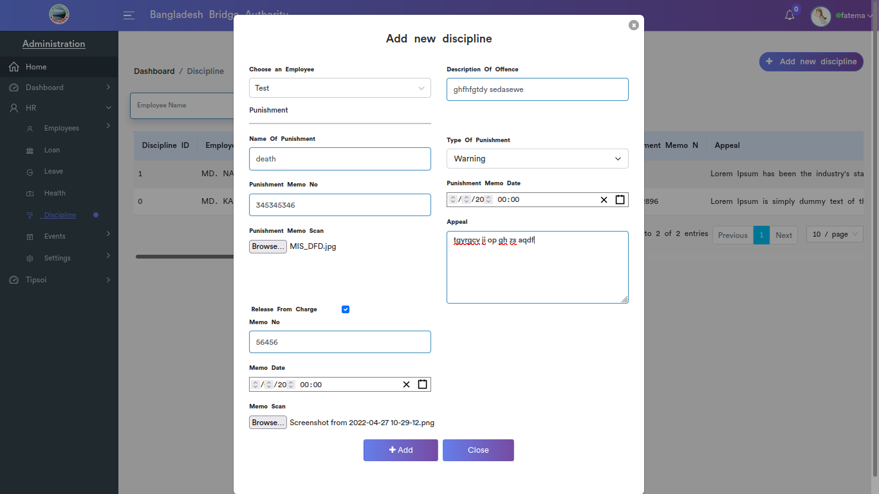

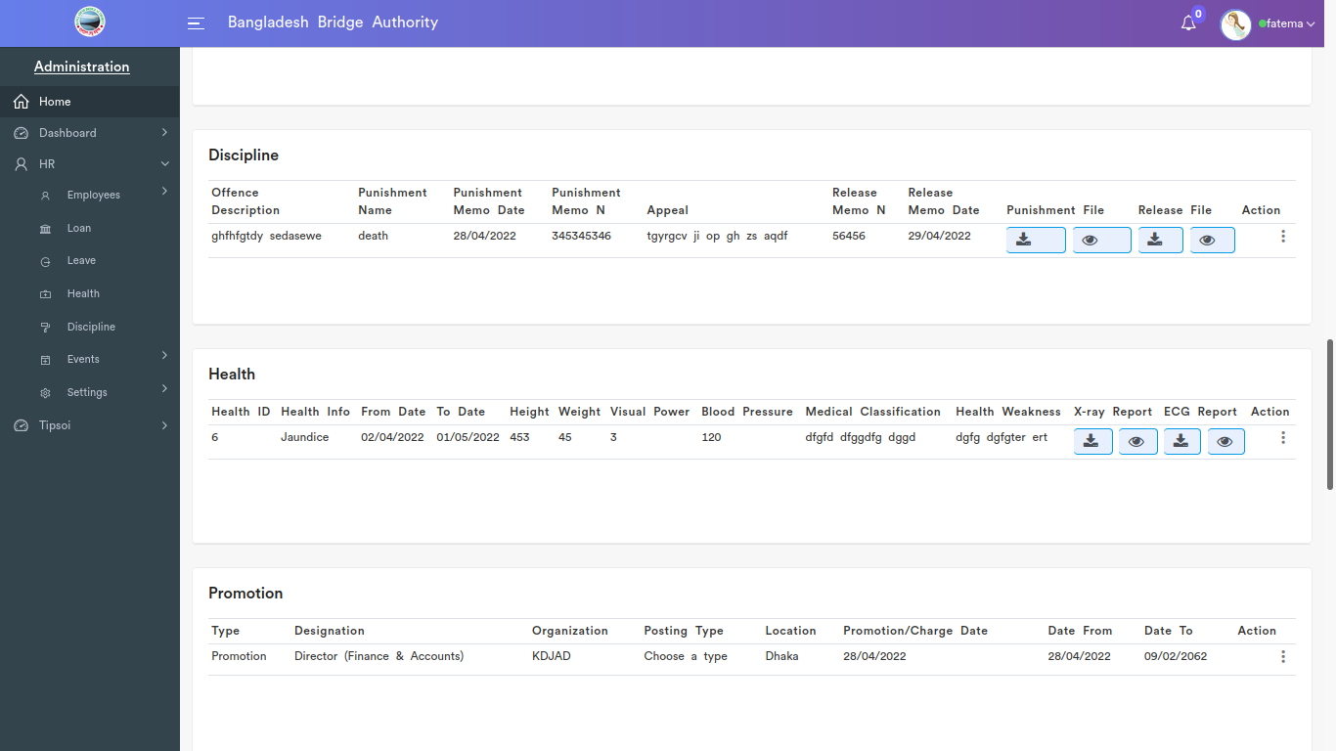

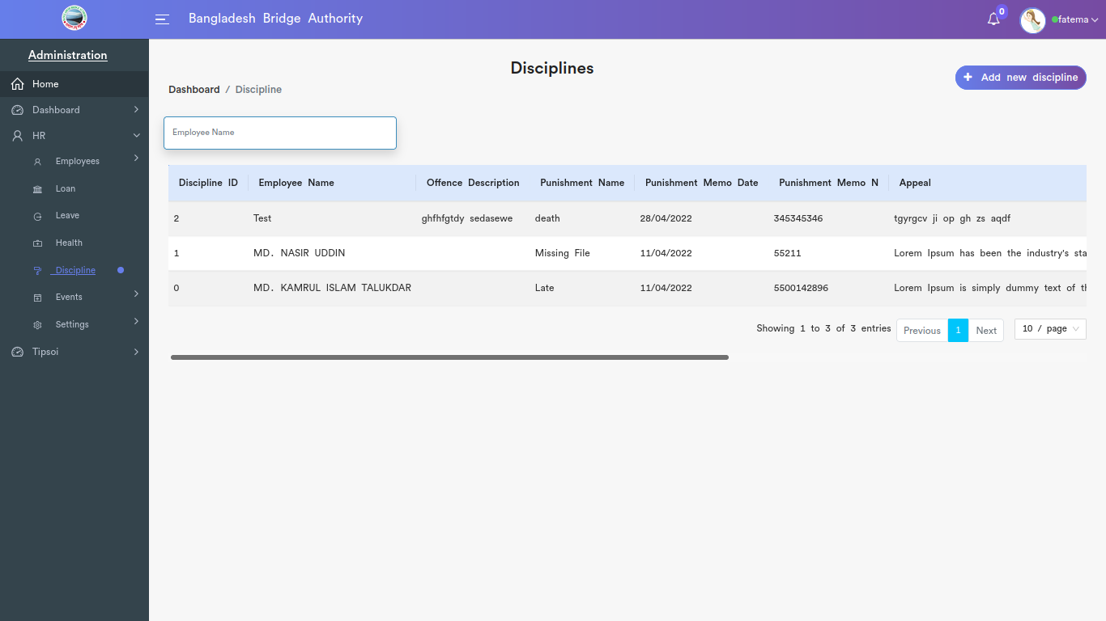

*Positive test case*

|  |  |  |  |  |  |
| --- | --- | --- | --- | --- | --- |
| Case ID | Title | Description | Expected Result | Actual Result | Pass/Fail |
| 1 | Add new Discipline | 1. Select employee  2. Describe offence  3. enter punishment name  4. select type of punishment  5. Enter punishment memo no  6. select punishment memo date  7. upload punishment memo copy  8. enter appeal  9. enter memo no to release  10. select memo date  11. upload memo  12. click add or skip | Data saved successfully | No error is displayed | P |
| 2 | Disciplines | 1. click search and type a employee name to find his/her discipline  2. click edit to update discipline information and generate a reported  3. click delete to delete discipline information | Action button does the specific operation | Works fine & displayed | P |

*Negative Test Case*

|  |  |  |  |  |  |
| --- | --- | --- | --- | --- | --- |
| Case ID | Title | Description | Expected Result | Actual Result | Pass/Fail |
| 1 | Add new Discipline | 1. employee and punishment type should be selected and punishment information should be entered  2. date should be selected in valid format  3. memo scan copy should be uploaded as well as other gap should be filled up | Data are valid and ok | No irrelevant data | P |
| 2 | Disciplines | Can be deleted successfully and edit button can generate report and make a copy of document of that report | Operation is perfectly done | No error occurred | P |

**6. EVENTS**

I. Dashboard

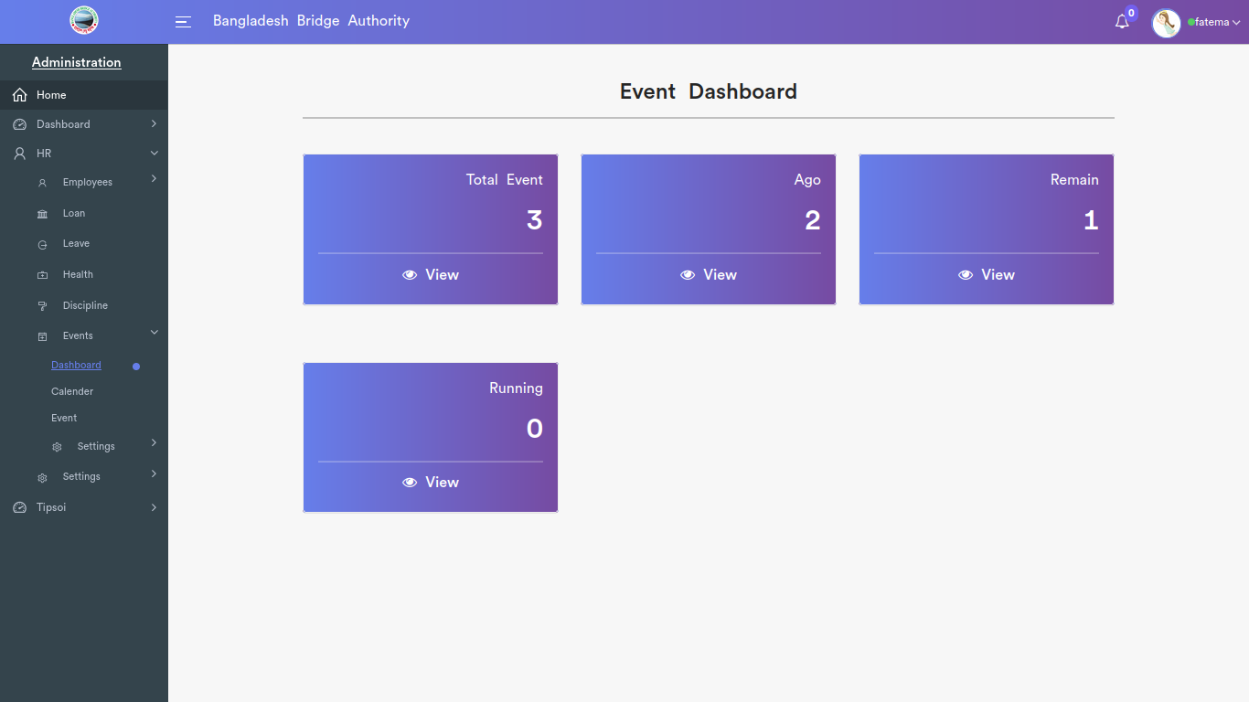

*Positive test case*

|  |  |  |  |  |  |
| --- | --- | --- | --- | --- | --- |
| Case ID | Title | Description | Expected Result | Actual Result | Pass/Fail |
| 1 | Total event | Click View total event list | Show the result perfectly | No error is found while displaying | P |
| 2 | Ago | Click View completed event list | Show the result perfectly | No error is found while displaying | P |
| 3 | Remain | Click View remain event list | Show the result perfectly | No error is found while displaying | P |
| 4 | Running | Click View Running event list | Show the result perfectly | No error is found while displaying | P |

*Negative Test Case*

|  |  |  |  |  |  |
| --- | --- | --- | --- | --- | --- |
| Case ID | Title | Description | Expected Result | Actual Result | Pass/Fail |
| 1 | Total event | No error occurred while showing the information | Works fine | No missing value in the list | P |
| 2 | Ago | No error occurred while showing the information | Works fine | No missing value in the list | P |
| 3 | Remain | No error occurred while showing the information | Works fine | No missing value in the list | P |
| 4 | Running | No error occurred while showing the information | Works fine | No missing value in the list | P |

ii. Calender

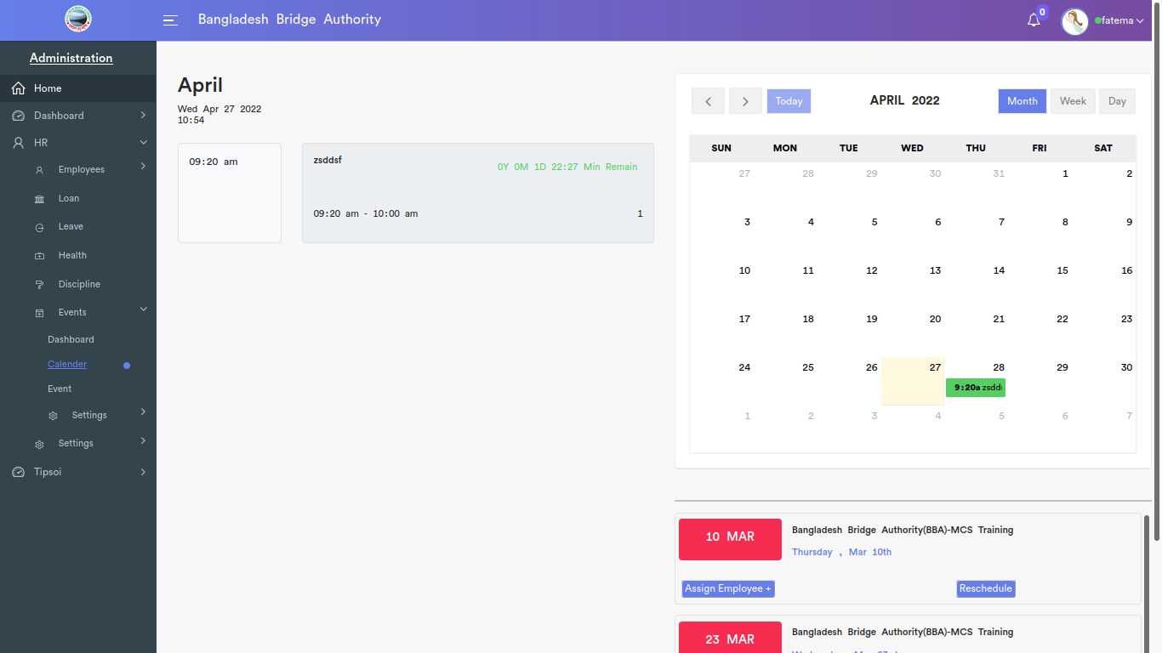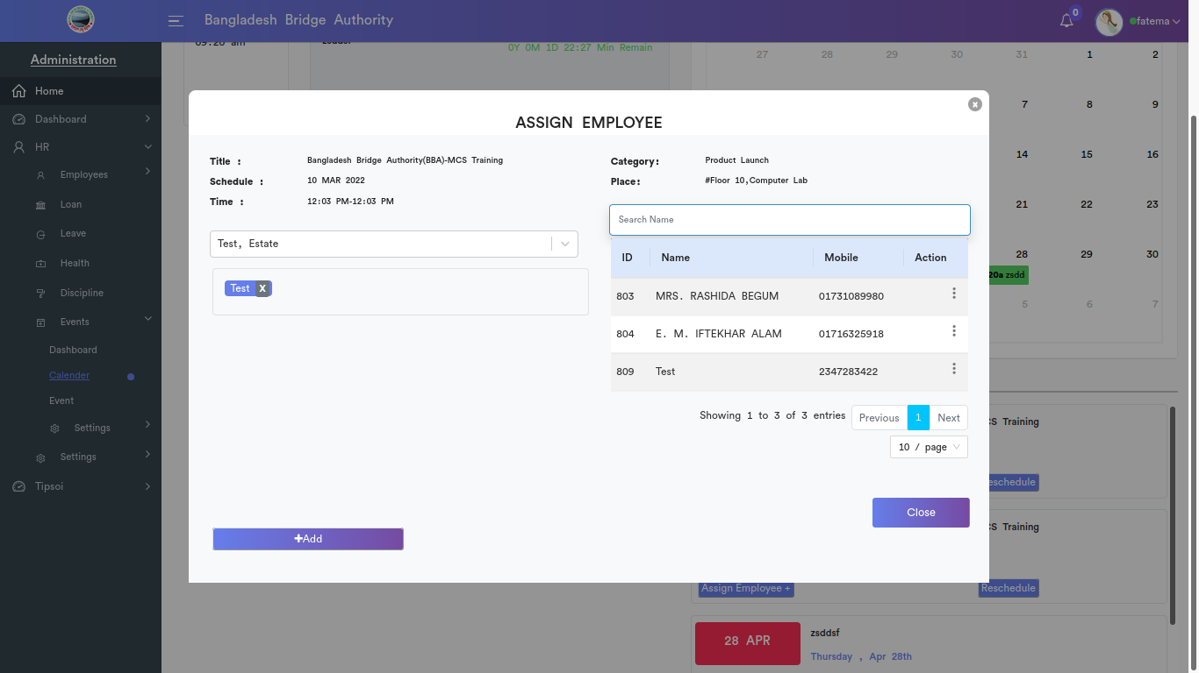

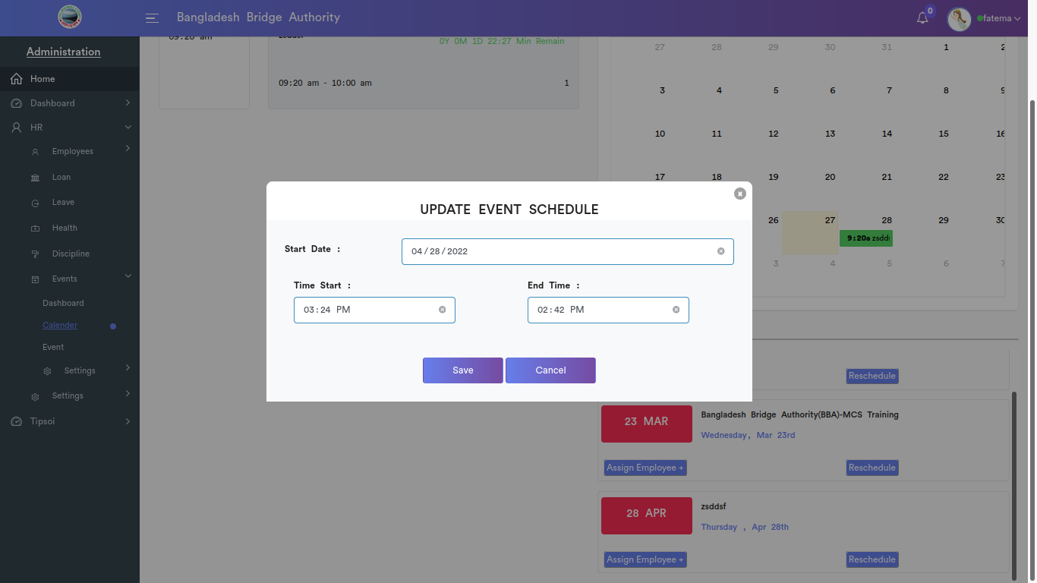

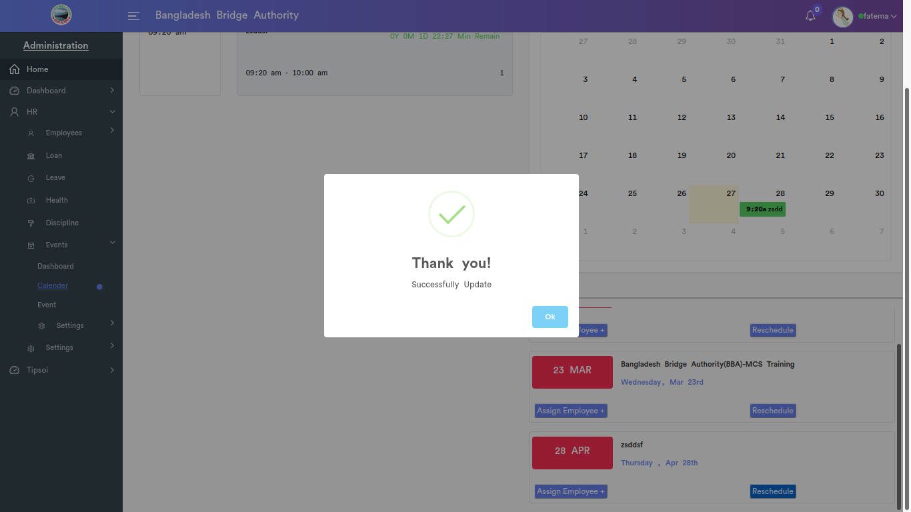

*Positive test case*

|  |  |  |  |  |  |
| --- | --- | --- | --- | --- | --- |
| Case ID | Title | Description | Expected Result | Actual Result | Pass/Fail |
| 1 | Assign employee | 1. enter employee  2. search event name  3. click add | Data saved successfully | No error is displayed | P |
| 2 | Update event schedule | 1. Select start date and enter start, end time  2. click save or cancel | Data saved successfully | No error is displayed | P |
| 3 | Event list | Display all the event list | Action button does the specific operation | Works fine & displayed | P |

*Negative Test Case*

|  |  |  |  |  |  |
| --- | --- | --- | --- | --- | --- |
| Case ID | Title | Description | Expected Result | Actual Result | Pass/Fail |
| 1 | Assign employee | Employee should be selected or can search through search option | Data are valid and ok | No irrelevant data | P |
| 2 | Update event schedule | Update schedule time by selecting date and time | Data are valid and ok | No irrelevant data | P |
| 3 | Event list | No error while showing the list | Operation is perfectly done | No error occurred | P |

iii. Event

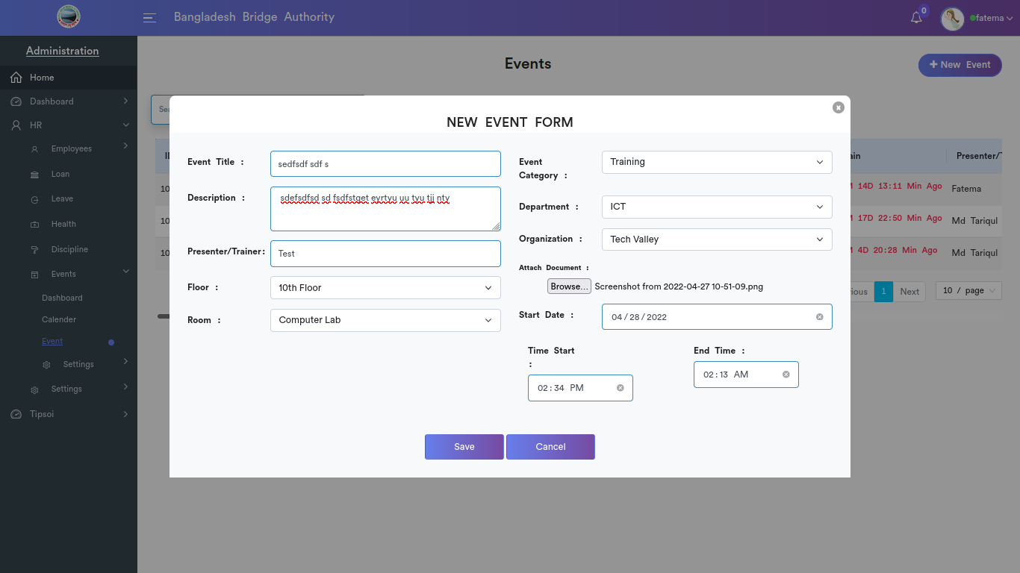

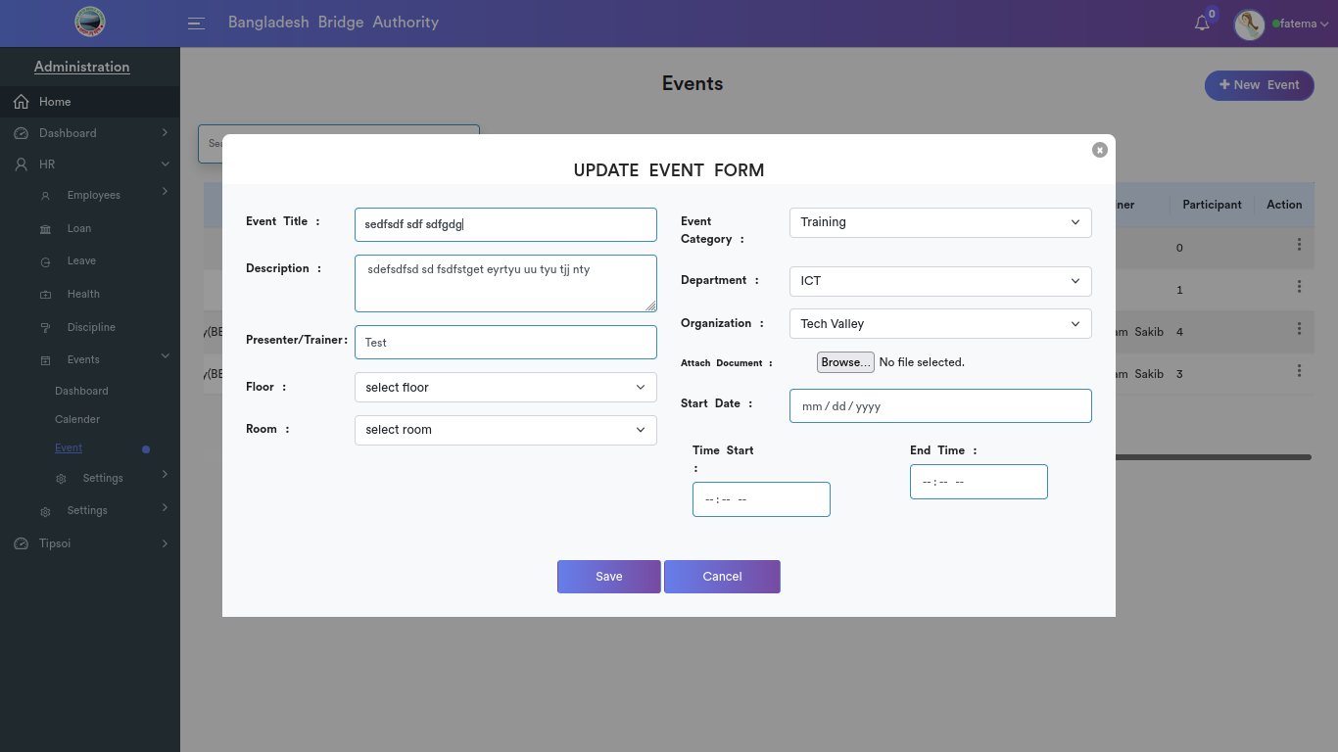

*Positive test case*

|  |  |  |  |  |  |
| --- | --- | --- | --- | --- | --- |
| Case ID | Title | Description | Expected Result | Actual Result | Pass/Fail |
| 1 | New event form | 1. Enter event title  2. event category  3. write event description  4. select department  5. select trainer/presenter  6. select organization  7. Select floor & room  8. select date & enter time  9. click save or cancel | Data saved successfully | No error is displayed | P |
| 2 | Events | 1. click search and type a event name to find that event information  2. click edit to update event details  3. click assign employee to assign an employee to a specific event  4. click delete to delete event | Action button does the specific operation | Works fine & displayed | P |

*Negative Test Case*

|  |  |  |  |  |  |
| --- | --- | --- | --- | --- | --- |
| Case ID | Title | Description | Expected Result | Actual Result | Pass/Fail |
| 1 | New event form | 1. Event title, description, presenter should be defined  2. floor, category, department, organization should be selected | Data are valid and ok | No irrelevant data | P |
| 2 | Events | 1. assign a employee for a specific event  2. event list has a update form | Operation is perfectly done | No error occurred | P |

iv. Settings

Organization

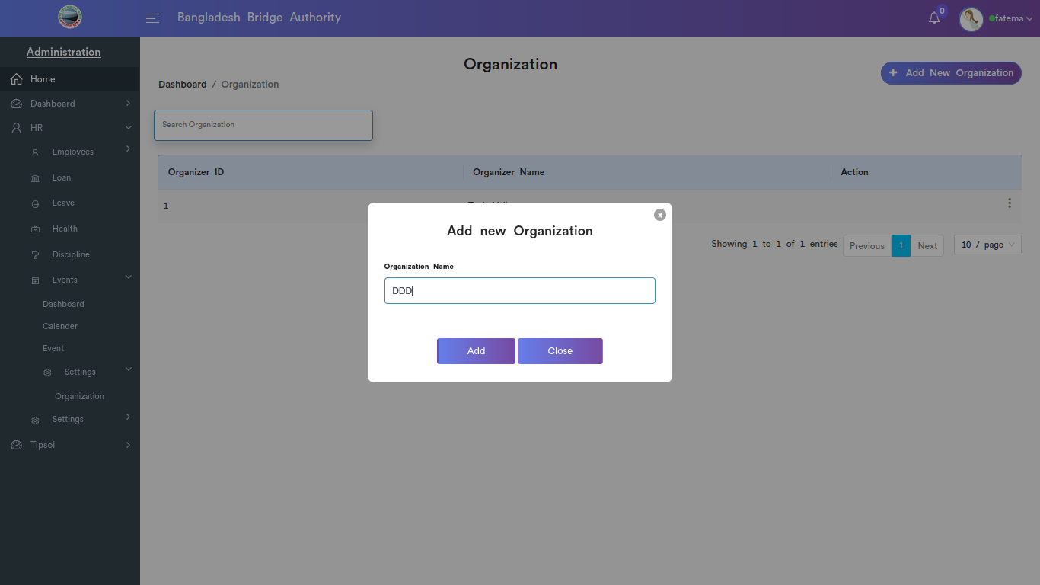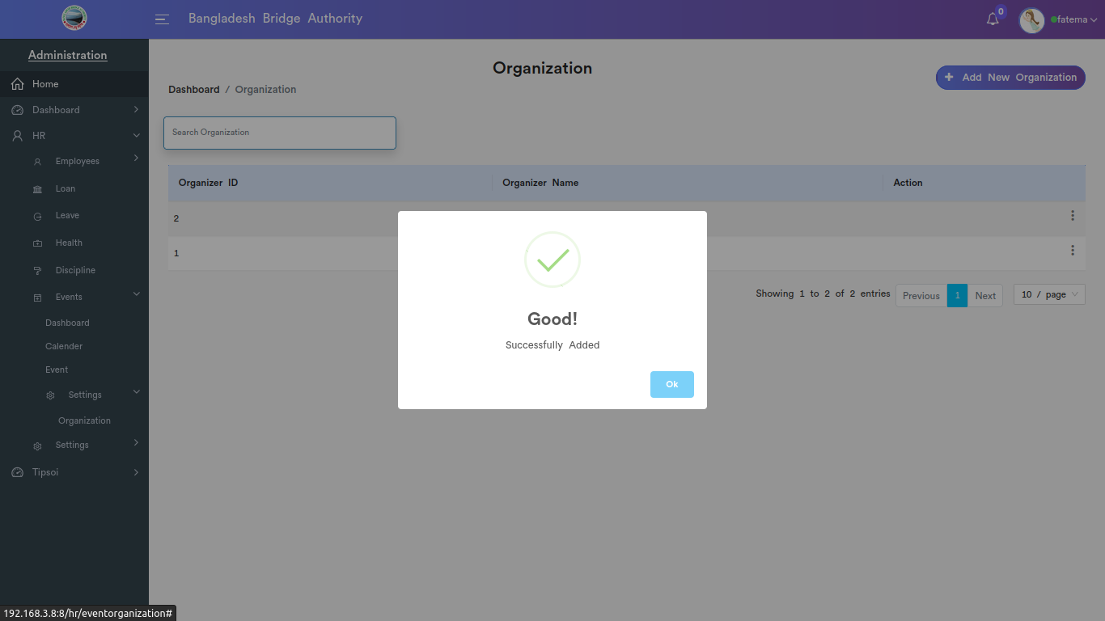

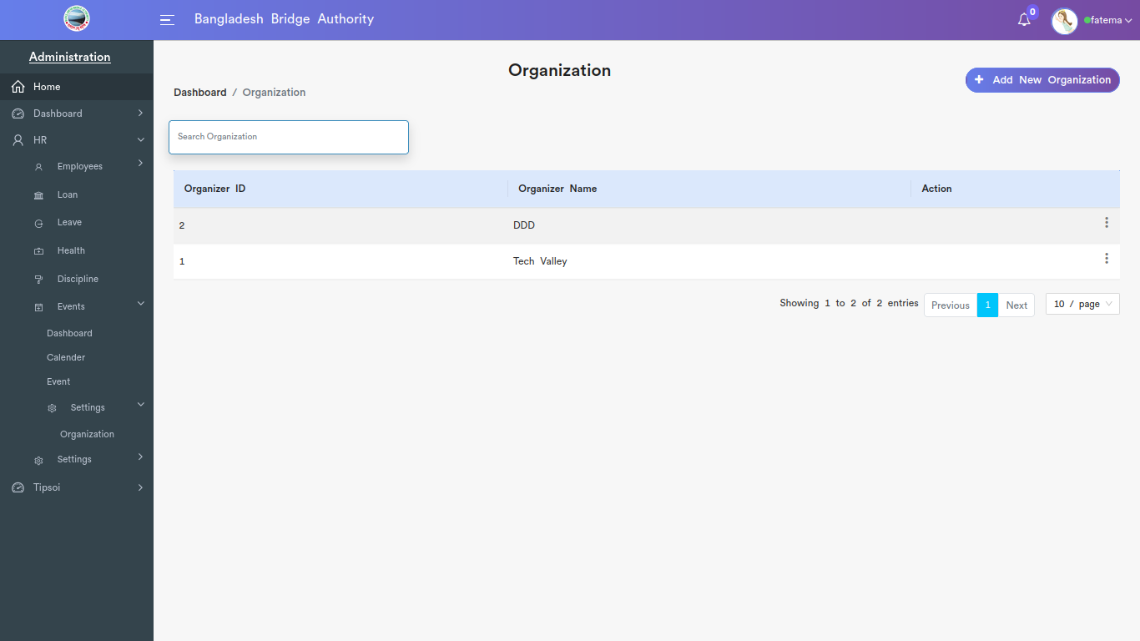

*Positive test case*

|  |  |  |  |  |  |
| --- | --- | --- | --- | --- | --- |
| Case ID | Title | Description | Expected Result | Actual Result | Pass/Fail |
| 1 | Add new organization | 1. Enter organization name  2. Click Add | Data saved successfully | No error is displayed | P |
| 2 | List | Display all the Organization name list | Action button does the specific operation | Works fine & displayed | P |

*Negative Test Case*

|  |  |  |  |  |  |
| --- | --- | --- | --- | --- | --- |
| Case ID | Title | Description | Expected Result | Actual Result | Pass/Fail |
| 1 | Add new organization | Entered information should perfectly saved | Data are valid and ok | No irrelevant data | P |
| 2 | List | No information is missing while displaying | Operation is perfectly done | No error occurred | P |

7. Settings

**1. Roles & Permissions**

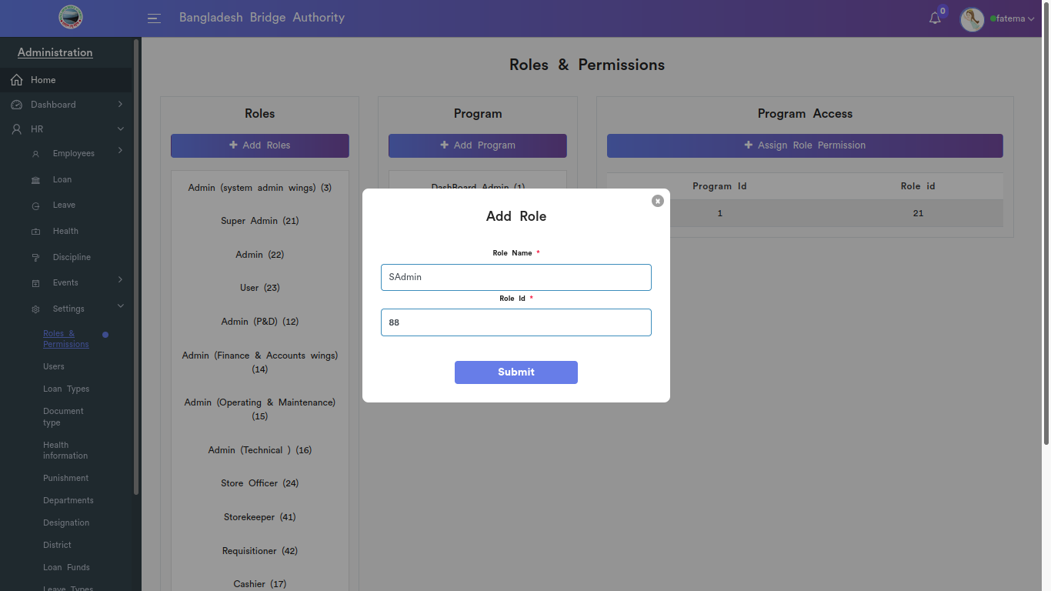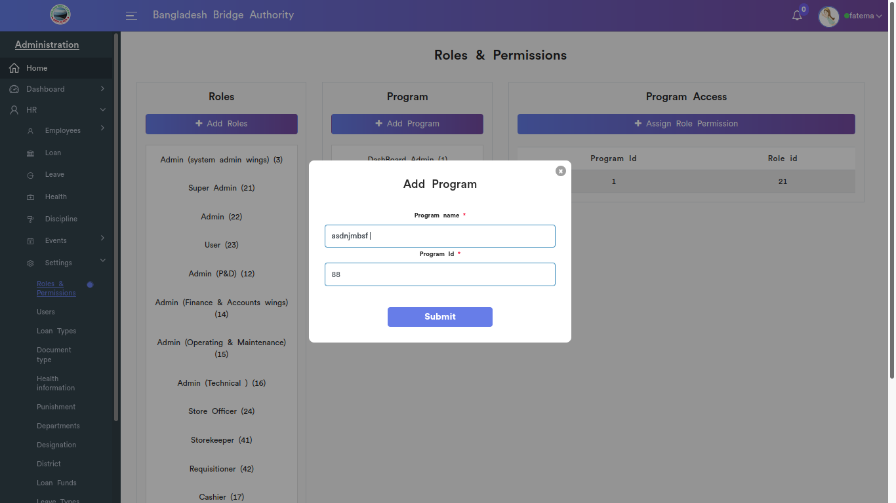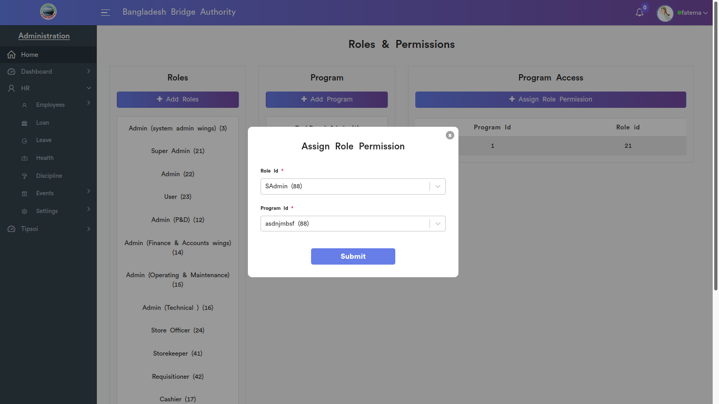

*Positive test case*

|  |  |  |  |  |  |
| --- | --- | --- | --- | --- | --- |
| Case ID | Title | Description | Expected Result | Actual Result | Pass/Fail |
| 1 | Roles | 1. enter role name  2. enter role id  3. click submit | Data saved successfully | No error is displayed | P |
| 2 | Programs | 1. enter program name  2. enter program id  3. click submit | Data saved successfully | No error is displayed | P |
| 3 | Program Access | 1. select role id  2. select program id  3. click submit | Data saved successfully | No error is displayed | P |

*Negative Test Case*

|  |  |  |  |  |  |
| --- | --- | --- | --- | --- | --- |
| Case ID | Title | Description | Expected Result | Actual Result | Pass/Fail |
| 1 | Roles | Role name & id should be filled up | Data are valid and ok | No irrelevant data | P |
| 2 | Programs | Program name and program id should be filled up | Data are valid and ok | No irrelevant data | P |
| 3 | Program Access | Both role id and program id should be selected | Data are valid and ok | No irrelevant data | P |

ii. Users

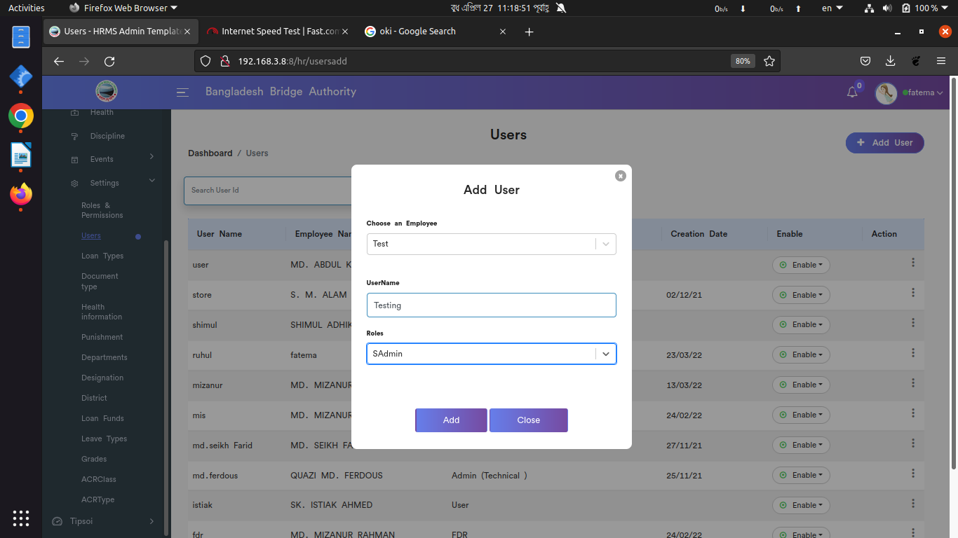

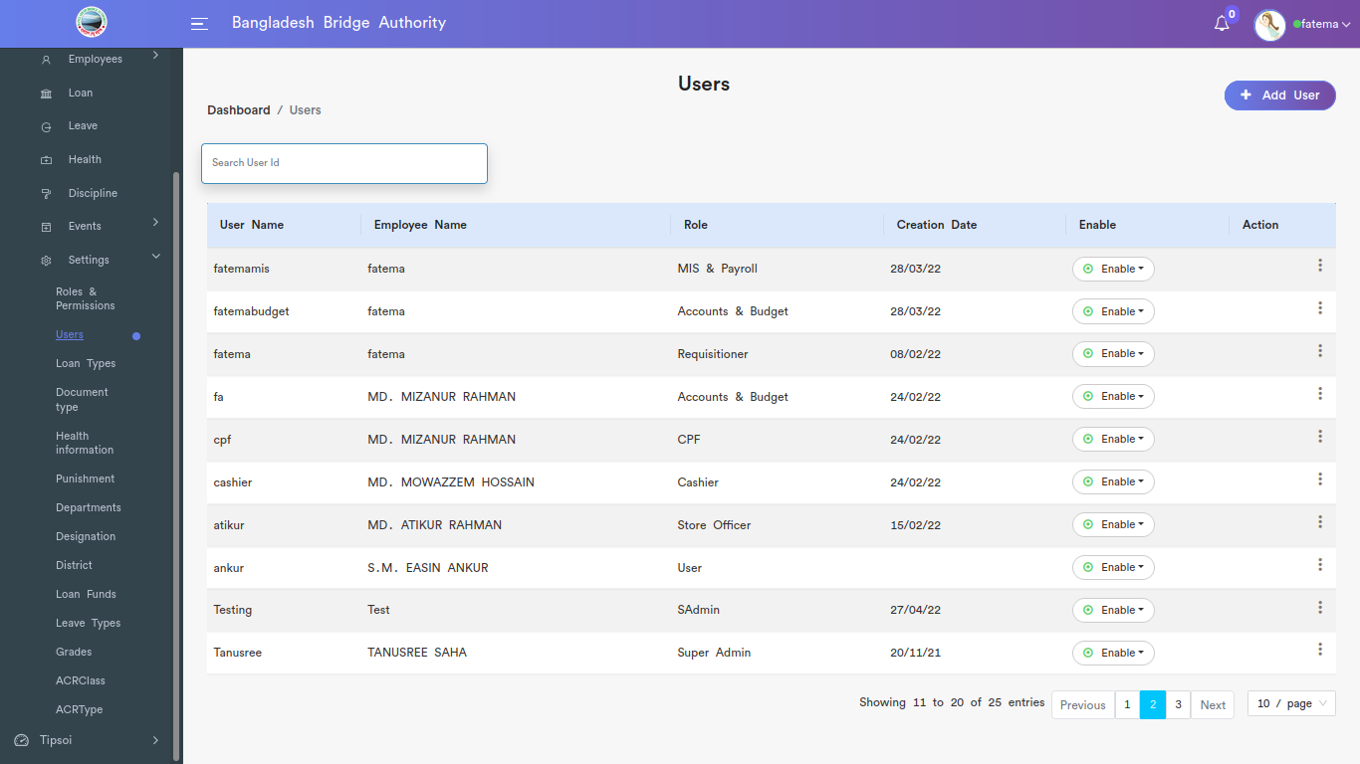

*Positive test case*

|  |  |  |  |  |  |
| --- | --- | --- | --- | --- | --- |
| Case ID | Title | Description | Expected Result | Actual Result | Pass/Fail |
| 1 | Add New User | 1. select employee  2. enter username  3. select roles  4. click add or cancel | Data saved successfully | No error is displayed | P |
| 2 | User | 1. click search and type a username to find his/her details  2. click edit to update user’s role  3. click update password to update password  4. click delete to delete user | Action button does the specific operation | Works fine & displayed | P |

*Negative Test Case*

|  |  |  |  |  |  |
| --- | --- | --- | --- | --- | --- |
| Case ID | Title | Description | Expected Result | Actual Result | Pass/Fail |
| 1 | Add New User | 1. Employee should be selected as user and have a username  2. must assign a role for a user | Data are valid and ok | No irrelevant data | P |
| 2 | User | 1. admin can enable or disable username  2. admin can edit roles and change user password | Operation is perfectly done | No error occurred | P |

iii. Loan Types

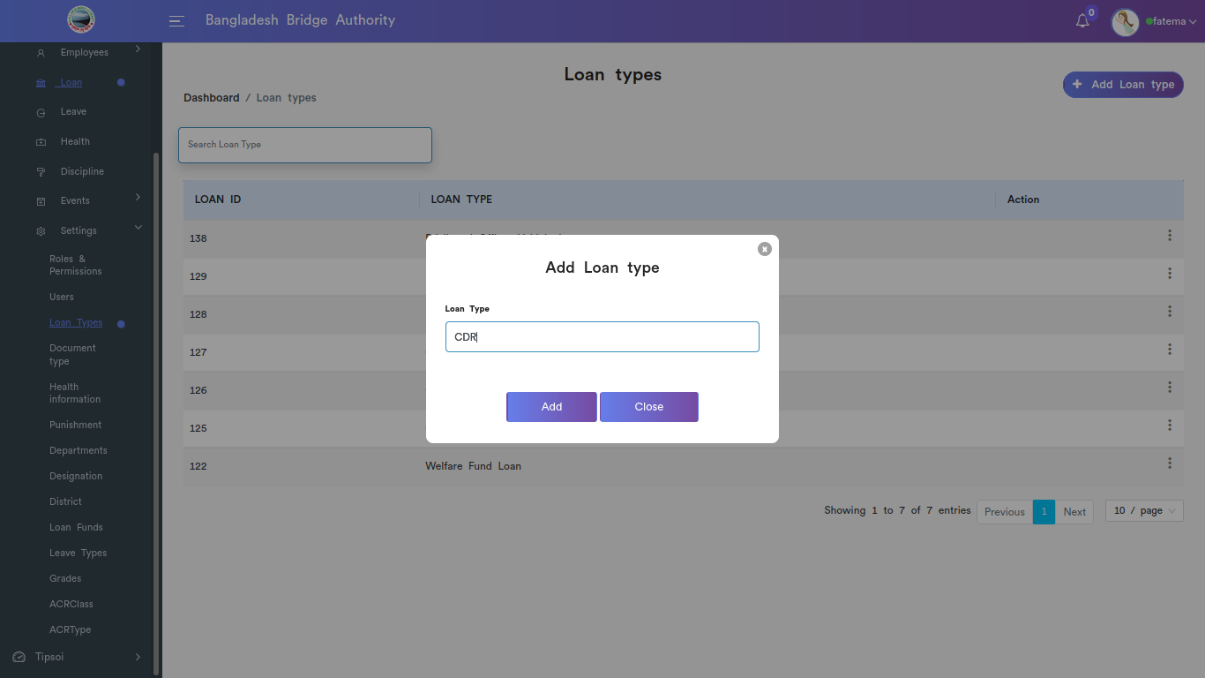

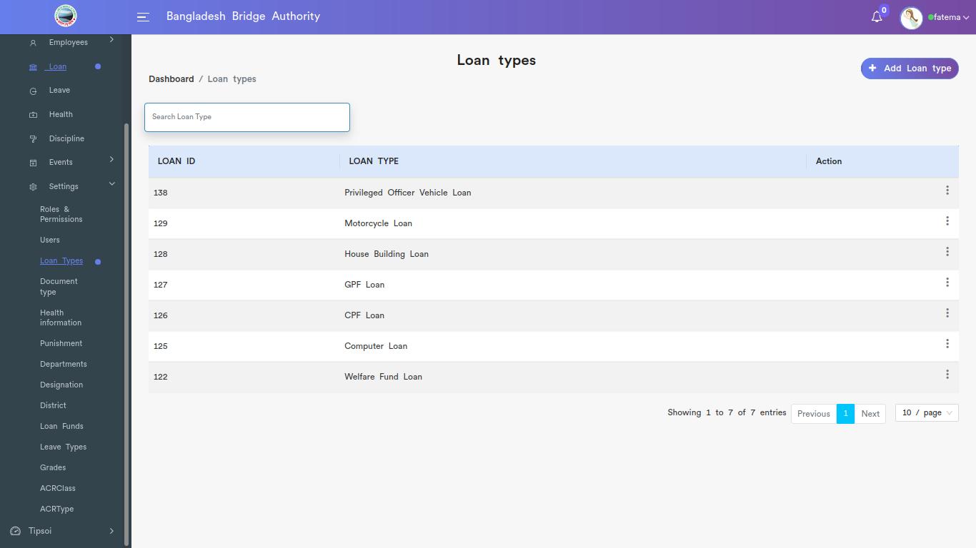

*Positive test case*

|  |  |  |  |  |  |
| --- | --- | --- | --- | --- | --- |
| Case ID | Title | Description | Expected Result | Actual Result | Pass/Fail |
| 1 | Add loan types | 1. Enter loan types  2. click add or close | Data saved successfully | No error is displayed | P |
| 2 | Loan types | 1. click search and write loan type  2. click update to update loan type or delete to delete loan type | Action button does the specific operation | Works fine & displayed | P |

*Negative Test Case*

|  |  |  |  |  |  |
| --- | --- | --- | --- | --- | --- |
| Case ID | Title | Description | Expected Result | Actual Result | Pass/Fail |
| 1 | Add loan types | Loan types should be on specific area | Data are valid and ok | No irrelevant data | P |
| 2 | Loan types | Delete and update option in the loan types list | Operation is perfectly done | No error occurred | P |

**iv. Document Type**

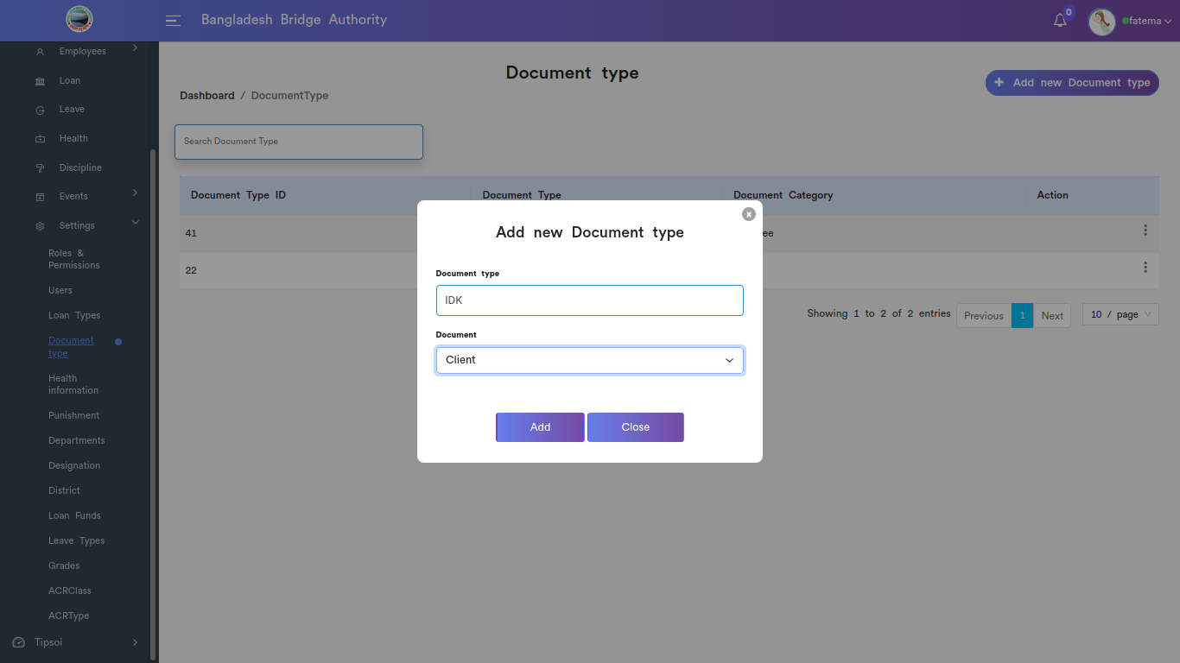

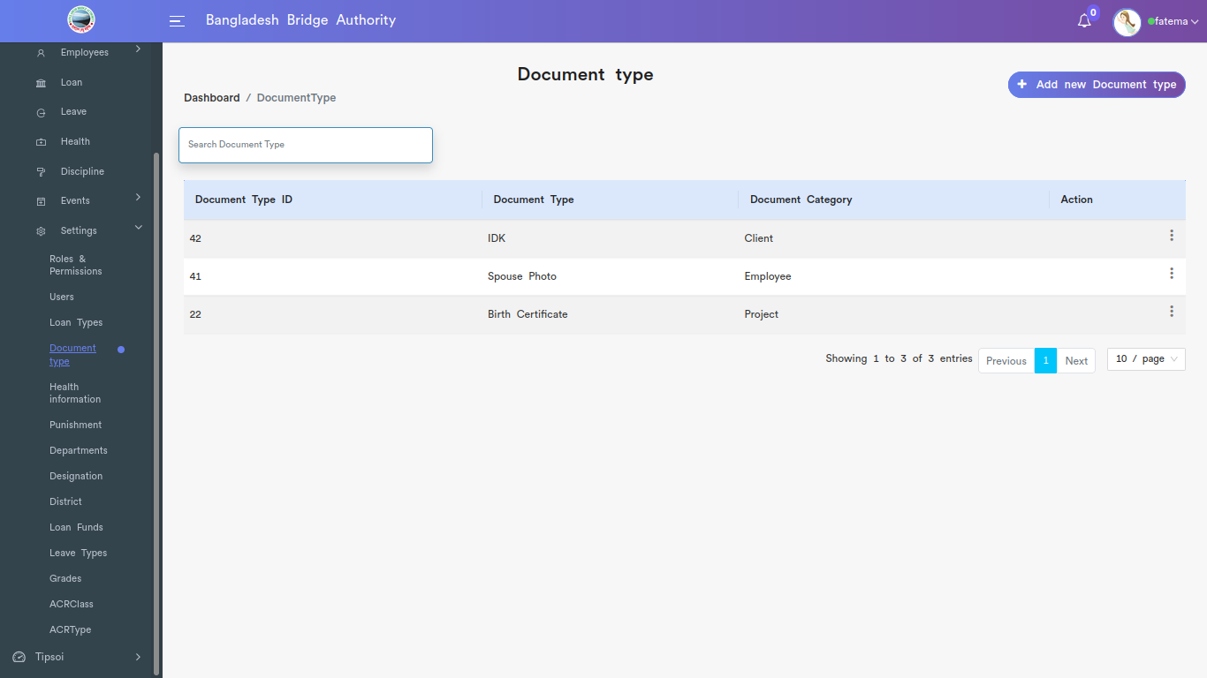

*Positive test case*

|  |  |  |  |  |  |
| --- | --- | --- | --- | --- | --- |
| Case ID | Title | Description | Expected Result | Actual Result | Pass/Fail |
| 1 | Add new Document Type | 1. Enter document type  2. select document  3. click add or cancel | Data saved successfully | No error is displayed | P |
| 2 | Document Type list | Option for edit or delete the document information | Action button does the specific operation | Works fine & displayed | P |

*Negative Test Case*

|  |  |  |  |  |  |
| --- | --- | --- | --- | --- | --- |
| Case ID | Title | Description | Expected Result | Actual Result | Pass/Fail |
| 1 | Add new Document Type | Should fill up document type and must select a document | Data are valid and ok | No irrelevant data | P |
| 2 | Document Type list | List should be operated | Operation is perfectly done | No error occurred | P |

v. Health Information

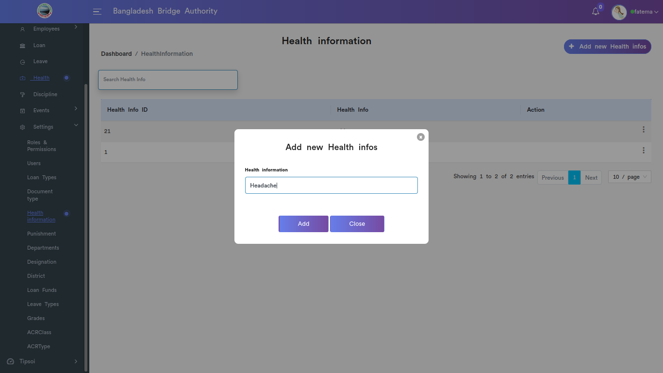

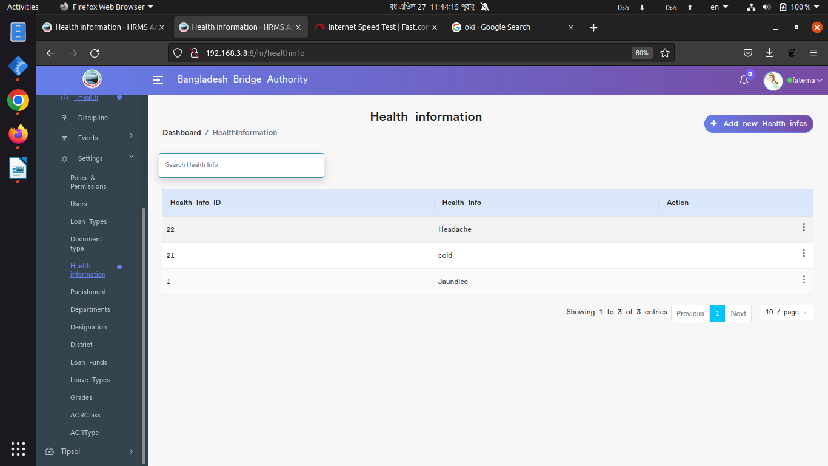

*Positive test case*

|  |  |  |  |  |  |
| --- | --- | --- | --- | --- | --- |
| Case ID | Title | Description | Expected Result | Actual Result | Pass/Fail |
| 1 | Add new health info | 1. Enter health information  2. click add or cancel | Data saved successfully | No error is displayed | P |
| 2 | Health information | 1. edit for update information  2 delete for deleting the health details | Action button does the specific operation | Works fine & displayed | P |

*Negative Test Case*

|  |  |  |  |  |  |
| --- | --- | --- | --- | --- | --- |
| Case ID | Title | Description | Expected Result | Actual Result | Pass/Fail |
| 1 | Add new health info | Information should on specific area | Data are valid and ok | No irrelevant data | P |
| 2 | Health information | edit and update operation should be performed | Operation is perfectly done | No error occurred | P |

vi. Punishment

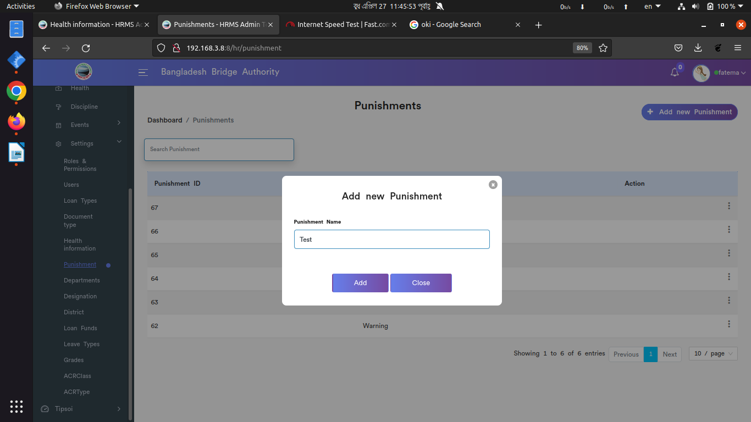

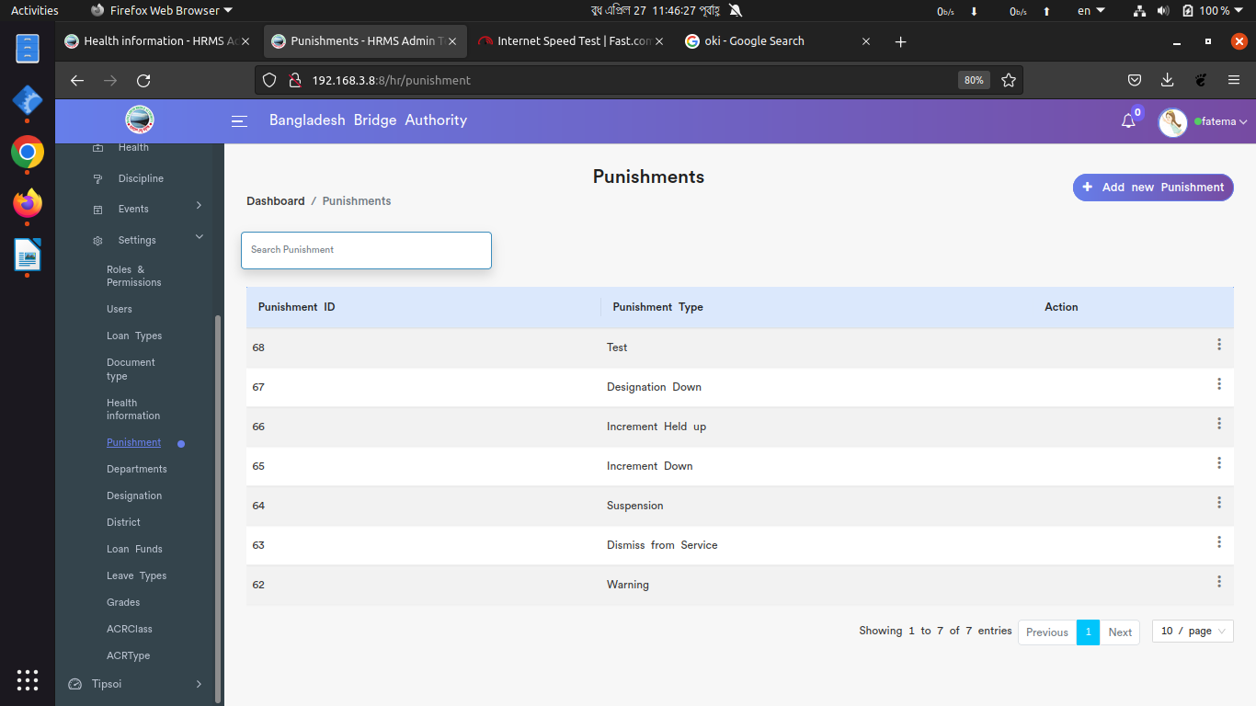

*Positive test case*

|  |  |  |  |  |  |
| --- | --- | --- | --- | --- | --- |
| Case ID | Title | Description | Expected Result | Actual Result | Pass/Fail |
| 1 | Add new punishment | 1. enter punishment name  2. click add or close window | Data saved successfully | No error is displayed | P |
| 2 | Punishment Type | 1. edit for update information  2 delete for deleting the punishment details | Action button does the specific operation | Works fine & displayed | P |

*Negative Test Case*

|  |  |  |  |  |  |
| --- | --- | --- | --- | --- | --- |
| Case ID | Title | Description | Expected Result | Actual Result | Pass/Fail |
| 1 | Add new punishment | Information should on specific area | Data are valid and ok | No irrelevant data | P |
| 2 | Punishment Type | edit and update operation should be performed | Operation is perfectly done | No error occurred | P |

vii. Departments

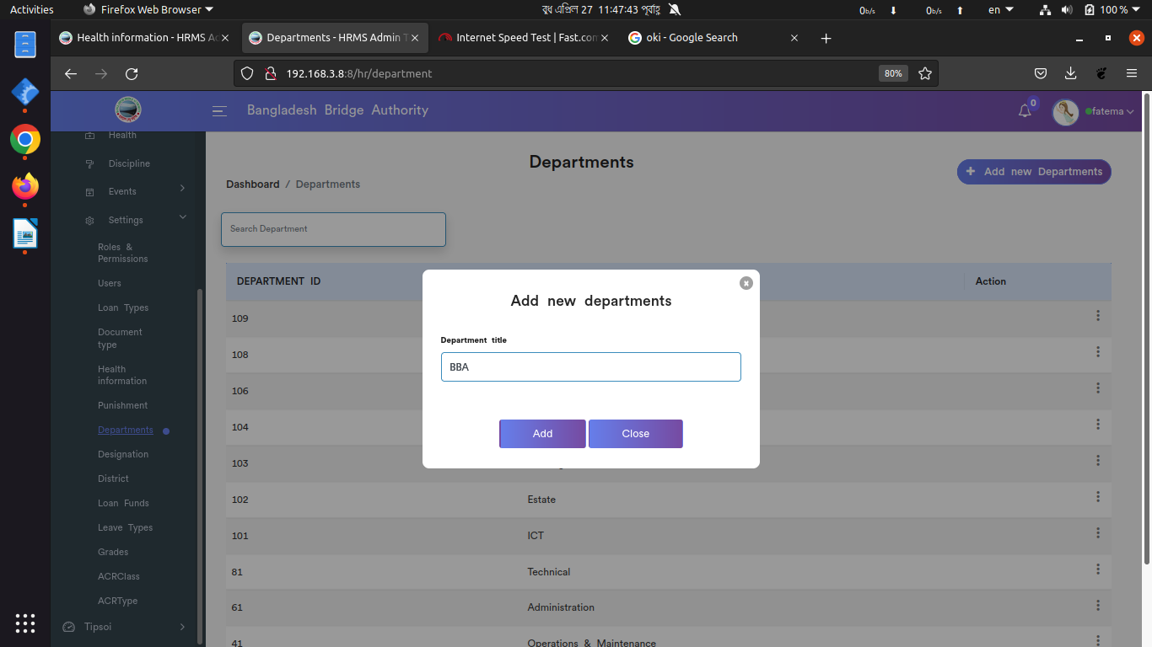

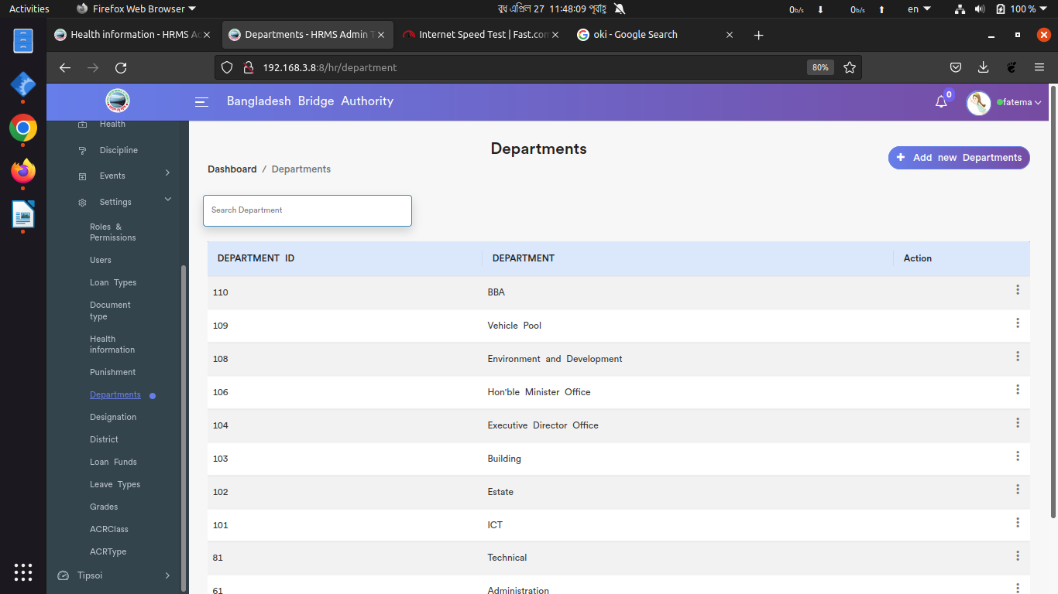

*Positive test case*

|  |  |  |  |  |  |
| --- | --- | --- | --- | --- | --- |
| Case ID | Title | Description | Expected Result | Actual Result | Pass/Fail |
| 1 | Add new department | 1. enter department name  2. click add or close window | Data saved successfully | No error is displayed | P |
| 2 | Department | 1. edit for update information  2 delete for deleting the department details | Action button does the specific operation | Works fine & displayed | P |

*Negative Test Case*

|  |  |  |  |  |  |
| --- | --- | --- | --- | --- | --- |
| Case ID | Title | Description | Expected Result | Actual Result | Pass/Fail |
| 1 | Add new department | Information should on specific area | Data are valid and ok | No irrelevant data | P |
| 2 | Department | edit and update operation should be performed | Operation is perfectly done | No error occurred | P |

Viii. Designation

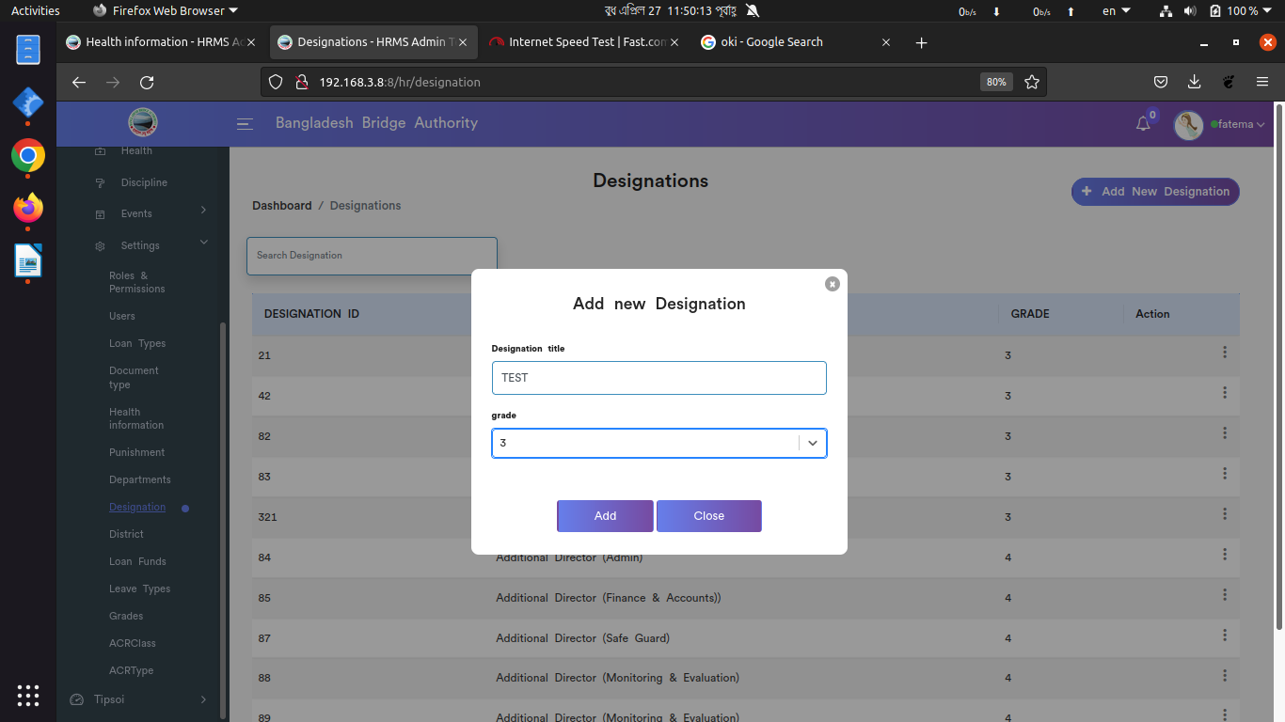

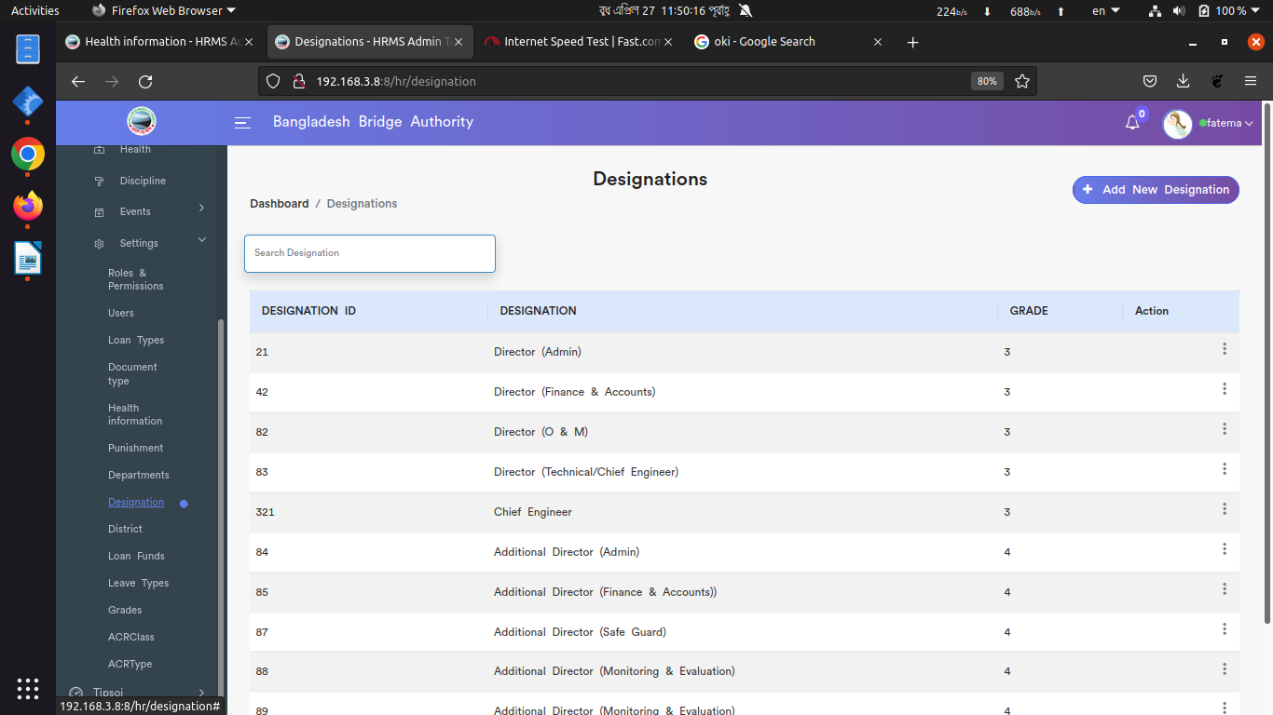

*Positive test case*

|  |  |  |  |  |  |
| --- | --- | --- | --- | --- | --- |
| Case ID | Title | Description | Expected Result | Actual Result | Pass/Fail |
| 1 | Add new designation | 1. enter designation name  2. select grade  3. click add or close window | Data saved successfully | No error is displayed | P |
| 2 | Designations | 1. edit for update information  2 delete for deleting the designation details | Action button does the specific operation | Works fine & displayed | P |

*Negative Test Case*

|  |  |  |  |  |  |
| --- | --- | --- | --- | --- | --- |
| Case ID | Title | Description | Expected Result | Actual Result | Pass/Fail |
| 1 | Add new designation | Information should on specific area and grade should be selected | Data are valid and ok | No irrelevant data | P |
| 2 | Designations | edit and update operation should be performed | Operation is perfectly done | No error occurred | P |

ix. District

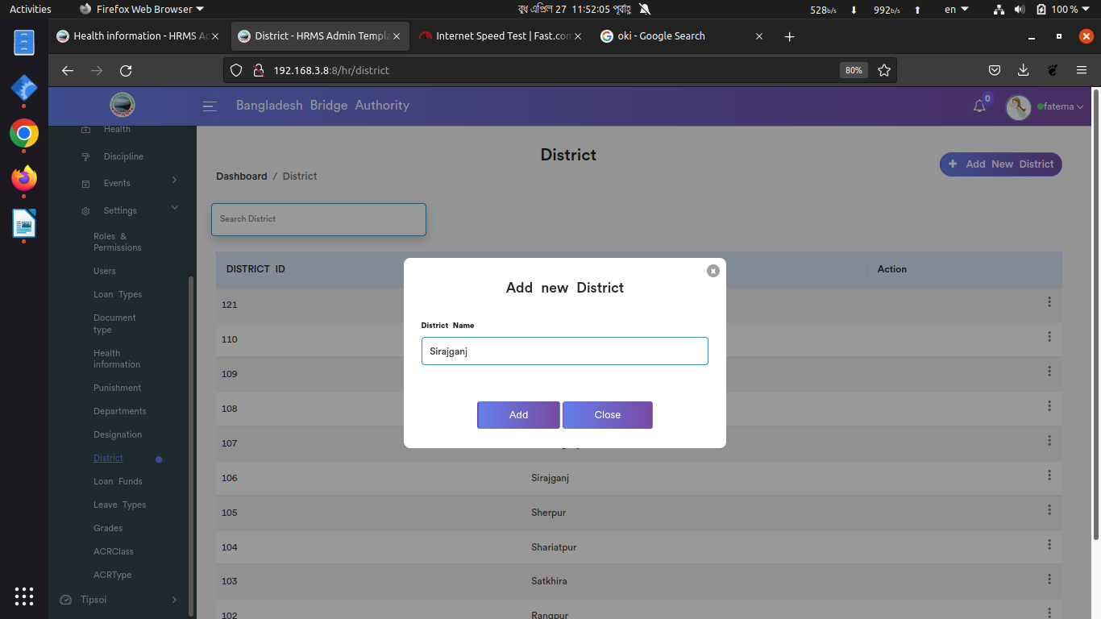

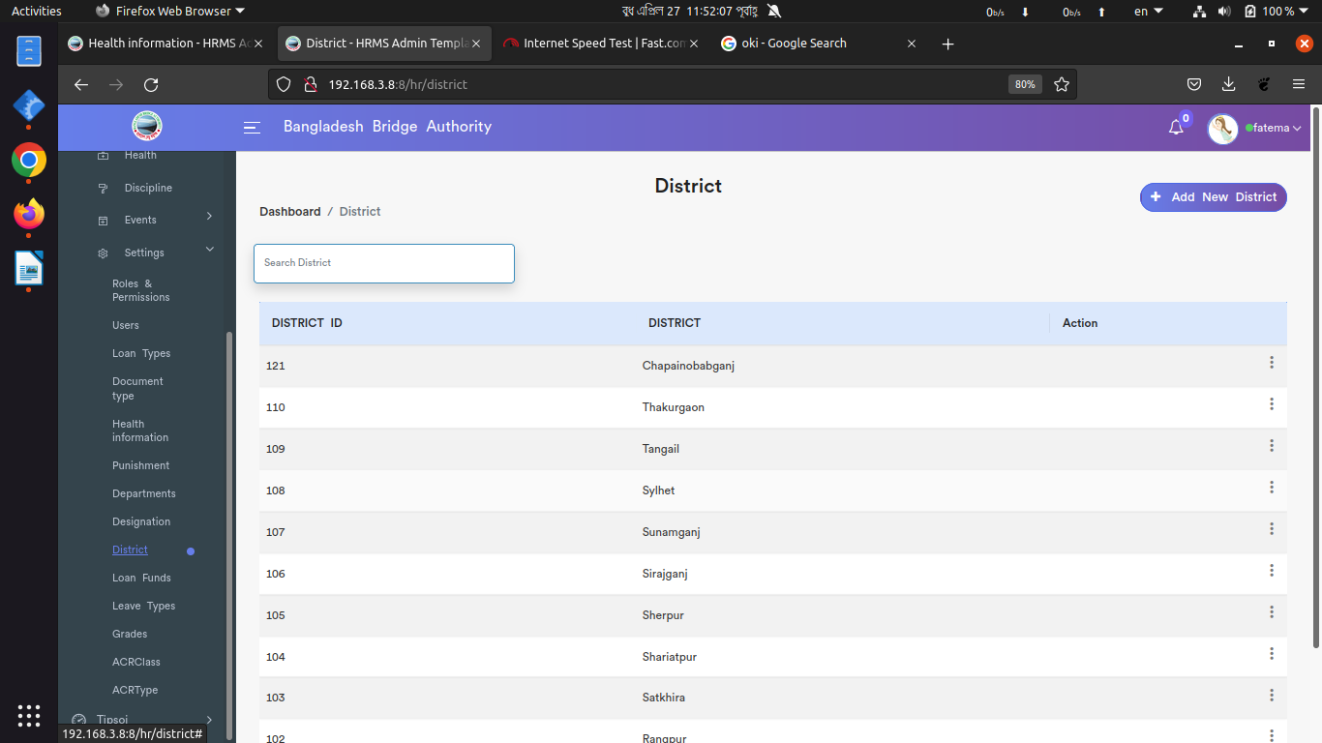

*Positive test case*

|  |  |  |  |  |  |
| --- | --- | --- | --- | --- | --- |
| Case ID | Title | Description | Expected Result | Actual Result | Pass/Fail |
| 1 | Add new District | 1. enter district name  2. click add or close window | Data saved successfully | No error is displayed | P |
| 2 | District | 1. edit for update information  2 delete for deleting the district details | Action button does the specific operation | Works fine & displayed | P |

*Negative Test Case*

|  |  |  |  |  |  |
| --- | --- | --- | --- | --- | --- |
| Case ID | Title | Description | Expected Result | Actual Result | Pass/Fail |
| 1 | Add new District | Information should on specific area | Data are valid and ok | No irrelevant data | P |
| 2 | District | edit and update operation should be performed | Operation is perfectly done | No error occurred | P |

x. Loan Funds

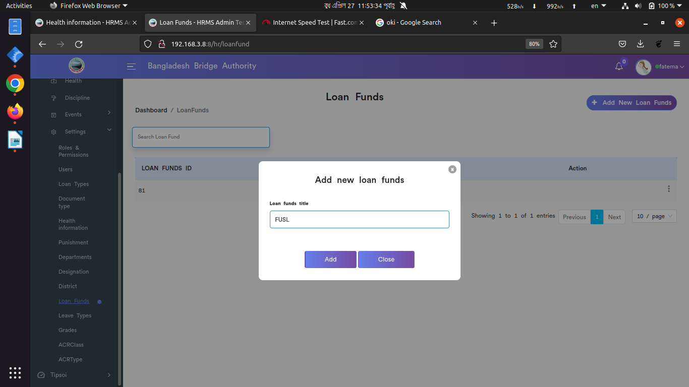

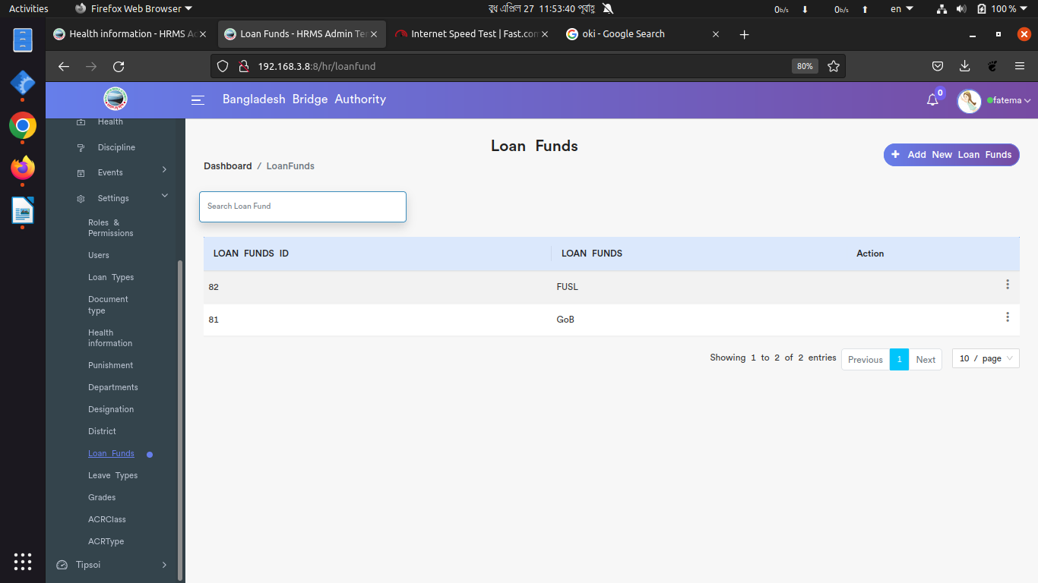

*Positive test case*

|  |  |  |  |  |  |
| --- | --- | --- | --- | --- | --- |
| Case ID | Title | Description | Expected Result | Actual Result | Pass/Fail |
| 1 | Add new loan funds | 1. enter new loan funds name  2. click add or close window | Data saved successfully | No error is displayed | P |
| 2 | Loan funds | 1. edit for update information  2 delete for deleting the loan funds details | Action button does the specific operation | Works fine & displayed | P |

*Negative Test Case*

|  |  |  |  |  |  |
| --- | --- | --- | --- | --- | --- |
| Case ID | Title | Description | Expected Result | Actual Result | Pass/Fail |
| 1 | Add new loan funds | Information should on specific area | Data are valid and ok | No irrelevant data | P |
| 2 | Loan funds | edit and update operation should be performed | Operation is perfectly done | No error occurred | P |

xi. Leave

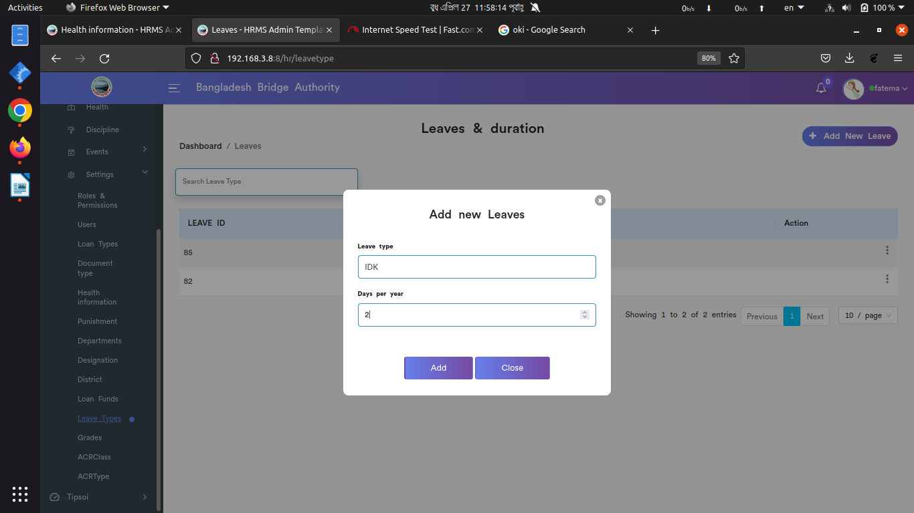

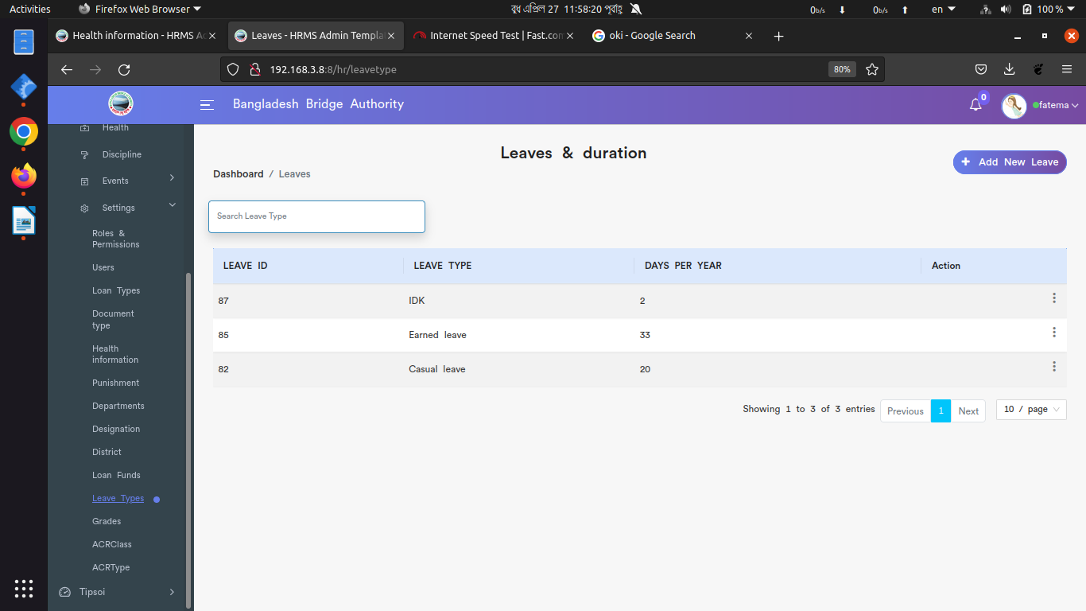

*Positive test case*

|  |  |  |  |  |  |
| --- | --- | --- | --- | --- | --- |
| Case ID | Title | Description | Expected Result | Actual Result | Pass/Fail |
| 1 | Add New leave | 1. enter leave types  2. Enter day per year  2. click add or close window | Data saved successfully | No error is displayed | P |
| 2 | Leave & duration | 1. edit for update information  2 delete for deleting the leave type details | Action button does the specific operation | Works fine & displayed | P |

*Negative Test Case*

|  |  |  |  |  |  |
| --- | --- | --- | --- | --- | --- |
| Case ID | Title | Description | Expected Result | Actual Result | Pass/Fail |
| 1 | Add New leave | Information should on specific area | Data are valid and ok | No irrelevant data | P |
| 2 | Leave & duration | edit and update operation should be performed | Operation is perfectly done | No error occurred | P |

Xii. Grades

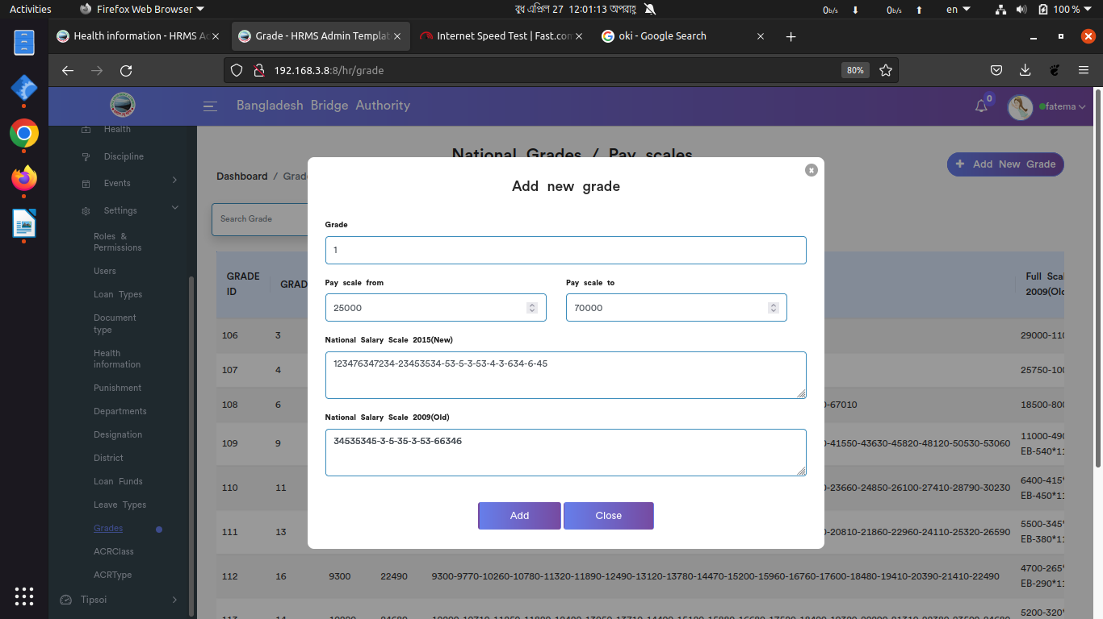



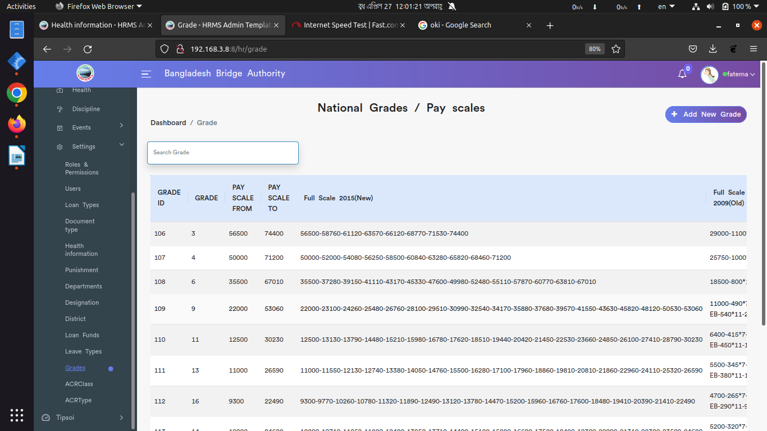

*Positive test case*

|  |  |  |  |  |  |
| --- | --- | --- | --- | --- | --- |
| Case ID | Title | Description | Expected Result | Actual Result | Pass/Fail |
| 1 | Add new grades | 1. enter grade  2. Enter pay scale from and to  2. click add or close window | Data saved successfully | No error is displayed | P |
| 2 | grades/pay-scale | 1. edit for update information  2 delete for deleting the grade details | Action button does the specific operation | Works fine & displayed | P |

*Negative Test Case*

|  |  |  |  |  |  |
| --- | --- | --- | --- | --- | --- |
| Case ID | Title | Description | Expected Result | Actual Result | Pass/Fail |
| 1 | Add new grades | Information should on specific area | Data are valid and ok | No irrelevant data | P |
| 2 | grades/pay-scale | edit and update operation should be performed | Operation is perfectly done | No error occurred | P |

Xiii. ACRClass

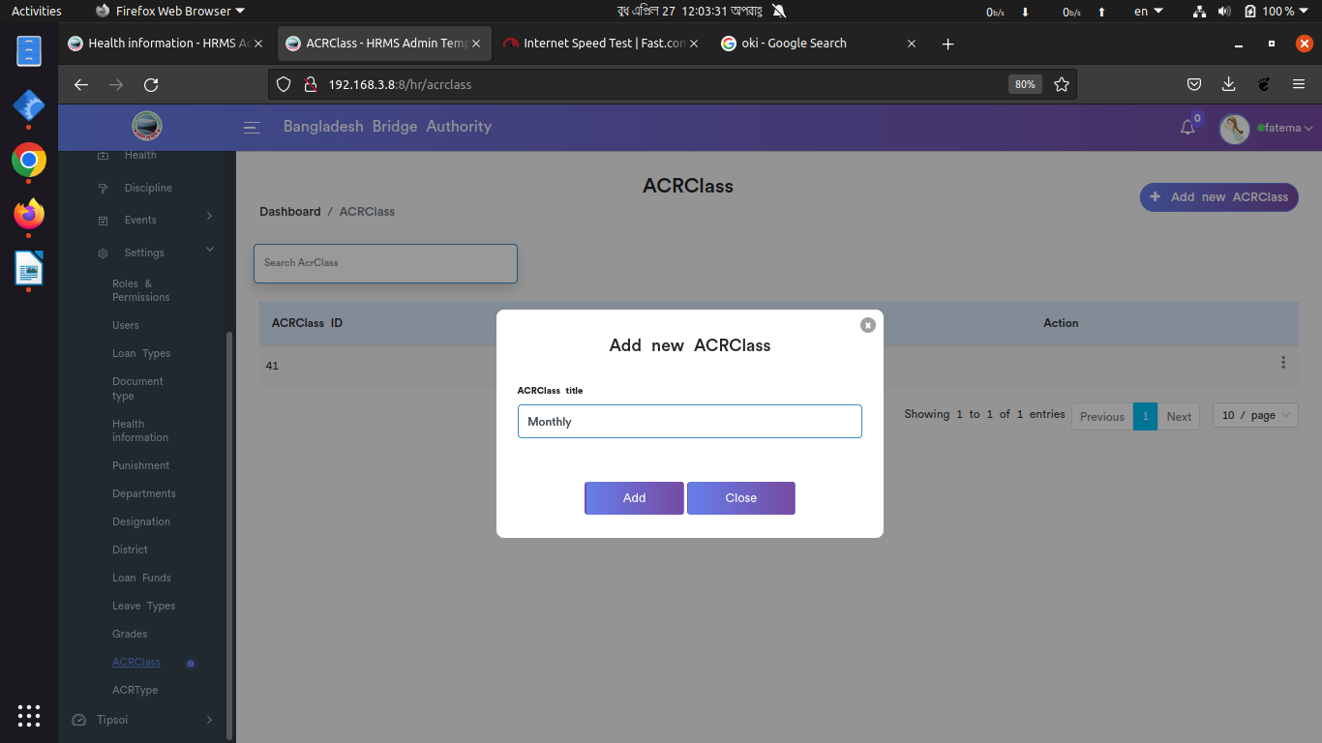

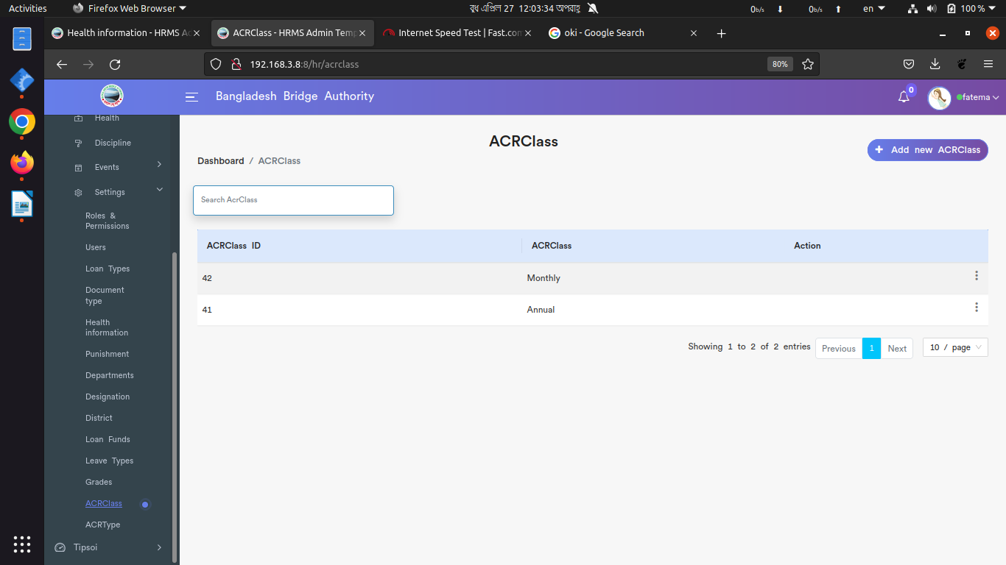

*Positive test case*

|  |  |  |  |  |  |
| --- | --- | --- | --- | --- | --- |
| Case ID | Title | Description | Expected Result | Actual Result | Pass/Fail |
| 1 | Add new ACR class | 1. enter ACR class  2. click add or close window | Data saved successfully | No error is displayed | P |
| 2 | ACR class list | 1. edit for update information  2 delete for deleting the ACR class details | Action button does the specific operation | Works fine & displayed | P |

*Negative Test Case*

|  |  |  |  |  |  |
| --- | --- | --- | --- | --- | --- |
| Case ID | Title | Description | Expected Result | Actual Result | Pass/Fail |
| 1 | Add new ACR class | Information should on specific area | Data are valid and ok | No irrelevant data | P |
| 2 | ACR class list | edit and update operation should be performed | Operation is perfectly done | No error occurred | P |

Xiv. ACRType

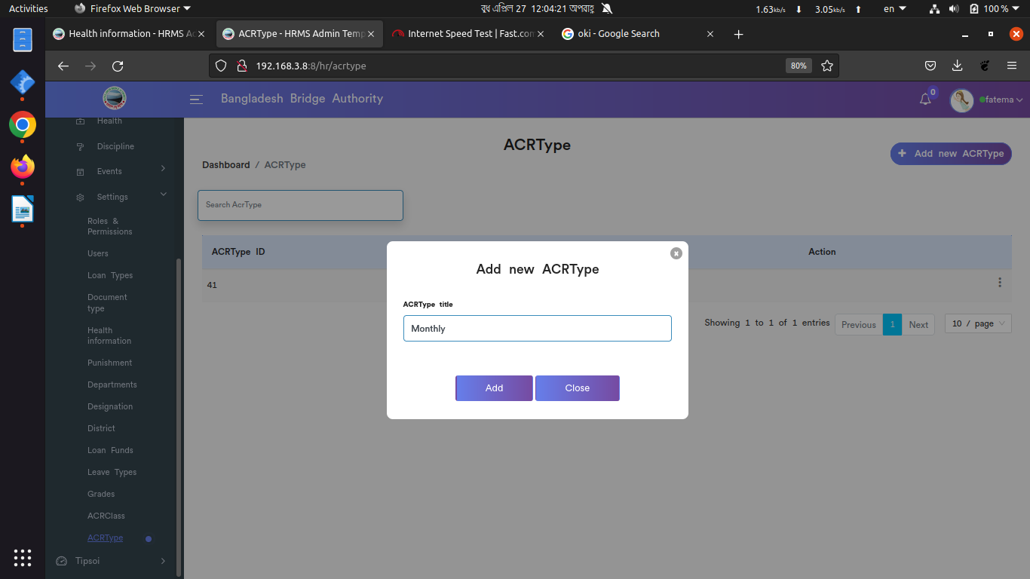

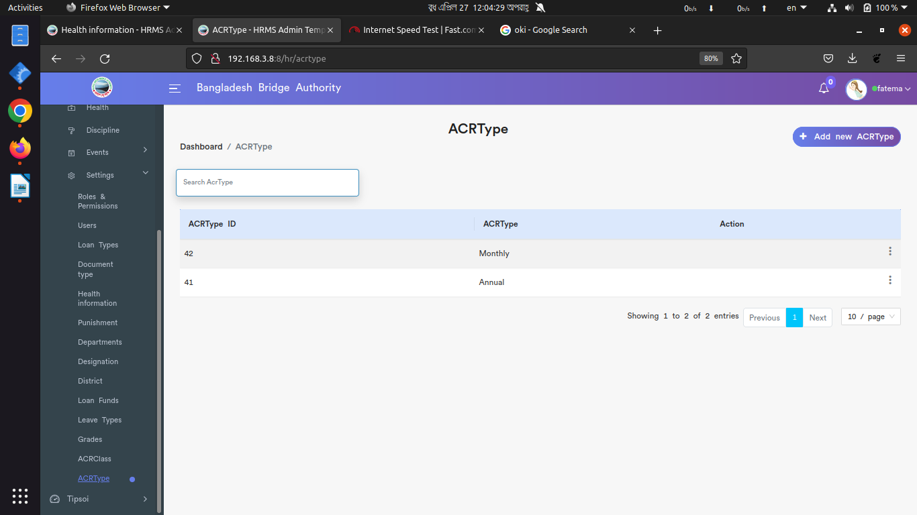

*Positive test case*

|  |  |  |  |  |  |
| --- | --- | --- | --- | --- | --- |
| Case ID | Title | Description | Expected Result | Actual Result | Pass/Fail |
| 1 | Add new ACR type | 1. enter ACR type  2. click add or close window | Data saved successfully | No error is displayed | P |
| 2 | ACR type list | 1. edit for update information  2 delete for deleting the ACR type details | Action button does the specific operation | Works fine & displayed | P |

*Negative Test Case*

|  |  |  |  |  |  |
| --- | --- | --- | --- | --- | --- |
| Case ID | Title | Description | Expected Result | Actual Result | Pass/Fail |
| 1 | Add new ACR type | Information should on specific area | Data are valid and ok | No irrelevant data | P |
| 2 | ACR Type list | edit and update operation should be performed | Operation is perfectly done | No error occurred | P |